Good Fire Restoration Plan [2023-2033]

[Property Name/Address]

Traditional Country of the [nation/tribe] people

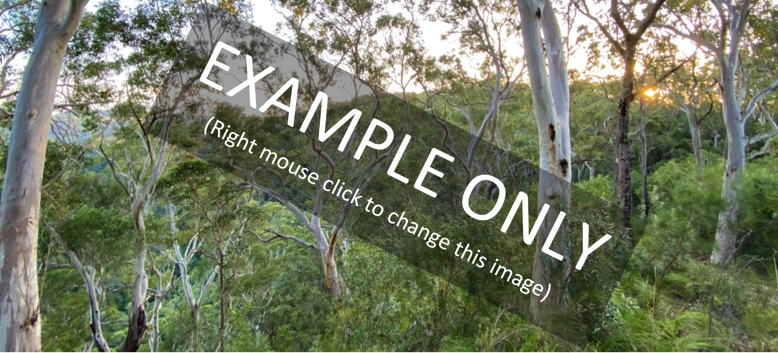

[Month Year]

Prepared by [Name of organisation that prepared Plan]

How to use this template Version 1 (June 2023)
This template is for cultural and ecological fire consultants to prepare Good Fire Restoration Plans. The restoration of fire regimes is a re-emerging aspect of land management in the region, and this template provides authors with a targeted and consistent approach for assessing and communicating altered fire regime issues relevant to this region.
When preparing a Plan, authors should also refer to the Good Fire – Healthy Country companion document that i) outlines key cultural and ecological concepts and ii) provides methods for the site-assessments needed to complete a Plan.
The template includes brief instructions for the author (italicised grey font) which are to be deleted from the final plan. The template also provides example text, tables and maps, which are to be edited or replaced by the consultant with information specific to the property. Text and figures which provide an overview of key ecological concepts should be retained in the final plan to help inform property owners and practitioners.

Table of Contents
1 Good Fire Overview 3
2 Plan Layout & Aims 4
3 Property Details 5
4 Conservation Values 7
5 Fire Management Issues 11
6 Maps 16
7 Good Fire Guidelines 22
8 Action Table 25
9 Disclaimer and Acknowledgements 27
10 Appendices 28

Acknowledgement of Country
We acknowledge the [nation/tribe] as the Traditional Custodians of this place. We recognise the lore and authority of Elders past and present. We respect their continuing connections and responsibilities to Country.

Good Fire Overview
Good fire is fire that enhances the health of the land and its people. At the time of European colonisation, Aboriginal and lightning fires were crucial elements throughout most of Byron Shire’s landscapes. Today however, cool, mosaic burning, and cool-season lightning fires have been largely extinguished, priming long-unburnt country to be ravaged by severe wildfires during prolonged droughts. This profound shift away from good fire is a major threat to biodiversity and severs a key pathway for Aboriginal custodians to connect with and care for country. Therefore, the restoration of good fire provides opportunities for all people to heal and reconnect with country and is crucial if we are to conserve the plants and animals that depend on our eucalypt and paperbark forests, heathlands and grasslands.
The desire to restore good fire arises from two different but overlapping community perspectives: traditional cultural practice and modern ecological restoration. At their core, both perspectives share the overarching vision of looking after country. However, each perspective also has its own system of values and protocols. This Good Fire Restoration Plan seeks to support the restoration of good fire in the Northern Rivers consistent with both cultural and ecological perspectives.

Cultural Fire
Cultural fire is the good ways Aboriginal people burn for Healthy Country through cultural lore and kinship. It is the cultural practice of First Nations people in many parts of the world. To maintain the cultural integrity of these practices they must be led or guided by Traditional Custodians with local knowledge, connections and authority. Healthy Country is critical for maintaining the kinship of the land and people connected to it. Traditionally local custodians regularly applied cultural fire to protect and improve the cultural resources and values to ensure safe and abundant landscapes. These practices were originally learnt from the naturally occurring fire regimes which can be both detrimental or beneficial to species and habitats. By learning the ways fire is good and bad, people learnt and shared knowledge on how to harness fire to shape the landscape. People evolved to carry fire for their own good and the good of their kin. The diversity of Country shaped Aboriginal people values and in turn these values shaped the land, which means it is critical to understand the local cultural values of Country before applying fire. When burning Country there are always winners and losers, with different species being favoured by different fire regimes. Cultural fire is about understanding that kinship between species and places to allow the ancestors of place to grow and regenerate, while adapting as systems interact and evolve.

Ecological Fire
Ecological fire is any fire that maintains the habitat and life cycles of the plants and animals found at a particular location. The open forests, heathlands and grasslands found in Byron Shire at European colonisation were finely adapted to Aboriginal fire but are now in sharp decline following its removal. The restoration of Aboriginal fire is crucial to maintain the environmental conditions required by open-ecosystem plants and the habitat structures required by open-ecosystem animals. The restoration of good fire can improve the resilience of open ecosystems to global change - keeping them in optimal condition, so that they can recover from extreme disturbances. Finally, if we are to conserve our fire-dependent biodiversity, it is vital that all land managers reconnect with fire as a keystone ecological process and that good fire practices are embedded in natural resource management programs related to fire-dependent ecosystems.

Plan Layout & Aims

Plan layout
This Good Fire Restoration Plan is an action plan that identifies the property’s conservation values and fire management issues and provides guidelines and actions to enable the restoration of good fire on the property.
A separate companion document, Good Fire – Healthy Country, provides background information on the role of fire in Aboriginal culture and the conservation of fire-dependent biodiversity to help practitioners and landowners better understand the plan’s rationale, guidelines and actions. It is recommended this companion document be read before preparing or reviewing a Good Fire Restoration Plan.

Plan aims and objectives
The aim of this Good Fire Restoration Plan is to protect and conserve ecological, cultural, carbon-sequestration and built values of the property through the restoration and maintenance of appropriate fire regimes.
The objectives of the Plan are to:
- maintain and improve open ecosystem habitat structure, composition and function (including carbon sequestration pathways) through the restoration of appropriate fire regimes
- minimise impacts from unplanned wildfires through ecologically and culturally appropriate planned burns
- to re-engage Aboriginal people with country through their cultural practices and responsibilities.

Property Details
Landowner’s Name
Land Tenure
Address
Lot and DP Details
Area (hectares)
Local Government Area

Property location & context
Provide a brief description (here) and map (replace example - Map 1 in Maps section) describing the context of the property within the surrounding local landscape. The map should show the following key features as appropriate:
- Neighbouring conservation areas (e.g. NPWS lands, Council bushland reserves)
- Lot boundaries
- Fire/smoke sensitive features on adjacent properties (e.g. major roads, schools, hospitals, major tourist facilities; agricultural crops)
Example text. The property comprises 48 hectares on the coastal foothills of Broken Head in the southeast of Byron Shire (Map 1). The property is located about 2 km south of the township of Suffolk Park and is part of the Traditional lands of the Bundjalung nation. Private lands to north, west and south of the property contain extensive remnant vegetation dominated by open forest and interspersed with rainforest and heathland. To the east it is bounded by Broken Head Nature Reserve dominated by a mosaic of littoral rainforest interspersed with open forest and headland grasslands. The Ti Tree Lake Aboriginal Area is located about 1 km to the north.

Environmental Planning Overlays
Provide a table and map (replace example - example Map 2 in Maps section) identifying all planning overlays that are applicable to the property (See Good Fire – Healthy Country for assessment methods – Appendix B1).
Environmental planning overlays for the property are identified in Table 1 and shown on Map 2. Potential approval pathways to undertake eco-cultural burns vary under different planning overlays, as shown in Table 1. Importantly, burns approved as hazard reduction under the Bushfire Environmental Assessment Code are exempt from requiring any additional approval under these planning overlays. Burns not using this hazard reduction pathway are to be conducted under one of the approval pathways identified below, as appropriate.
Table 1. Burn approval pathways for lands mapped under different environmental planning overlays on the property.
Environmental Planning Overlay | Potential burn approval pathways
Coastal wetland area  (SEPP - Resilience and Hazards – 2021) | Burning permitted only with development consent, unless burning is identified in a certified coastal management program.
Coastal wetland and littoral rainforest proximity area; Coastal environment area; Coastal use area  (SEPP - Resilience and Hazards – 2021) | Burning permitted if the consent authority is satisfied it will avoid impacts on the environment
C2 – Environmental Conservation Zone; C3 - Environmental Management Zone (Byron Local Environment Plan 2014) | Burns permitted without consent if carried out as ‘environmental protection works’.
Biodiversity Conservation Trust (BCT) agreement areas | Burns permitted without consent if burning is listed as a management action in a Biodiversity stewardship agreement, conservation area agreement or wildlife refuge agreement.

Conservation Values

Ecological values
Provide a brief description outlining the ecological values of the property under each section below (See Good Fire – Healthy Country for property assessment methods – Appendix B).
The property supports significant areas of [dry sclerophyll forest, swamp sclerophyll forest and rainforest] (Map 3), each of which provide important habitat for a range threatened plants and animals. The property’s key ecological values include:
- known or likely habitat for threatened plants (XX species), birds (XX), mammals (XX), frogs (XX), reptiles (XX), snails (XX) and insects (XX)
- threatened ecological communities including [swamp sclerophyll forest and littoral rainforest]
- is an important area of native vegetation within [Byron Council’s wildlife corridors]

Vegetation types and their relationship to fire
Provide a brief description, table and map (replace example - example Map 3) describing the major vegetation classes found on the property. The vegetation map should be based on Council’s vegetation layer but must have been ground truthed to the subformation level by site assessment (See Good Fire – Healthy Country for assessment methods – Appendix B2). The map should show the following, as applicable:
- Fire-dependent ecosystem classes (e.g. dry sclerophyll forest (grassy), coastal heathland)
- Fire-sensitive ecosystem classes (i.e. rainforest, mangroves, salt marsh)
- Recommended fire intervals for each ecosystem
- Cultural overlay of modified fire intervals (e.g. grassy pathways)
The remnant vegetation on the property contains [both fire dependent open ecosystems (70%) and fire-sensitive rainforest (30%)] as shown in Table 2 and Map 3. Fire-dependent vegetation includes [grassy Dry Sclerophyll Forest (3%), shrubby Dry Sclerophyll Forest (45%) and….].
Table 2. Vegetation classes found on the property and their recommended fire frequency (QPWS 2022).
Vegetation Classes | Recommended Fire Interval (years) | Area (ha.) | Proportion of remnant vegetation on property
Heathlands (Coastal) | 6 – 12
Dry Sclerophyll Forests
grassy | 1 – 6 | [3] | [6%]
shrubby | 4 -10 | [21] | [45%]
Swamp Sclerophyll Forest
grass / shrub | 6 – 20
heathy shrub | 8 – 12
sedge / fern | 12 -20
Wet Sclerophyll Forest
grassy | 3 – 5
fern / shrub | 8 – 20
rainforest | 20 – 100
Rainforest | No Fire
TOTAL | - | [70] | [100%]

Threatened species and their relationship to fire
Edit the tables in Appendix A to summarise the threatened flora, fauna and ecological communities (BC Act and EPBC Act) likely to occur on the property based on a BioNet search within a 5km radius of the property. Threatened species are to be grouped by their habitat’s relationship to fire (See Good Fire – Healthy Country for assessment methods – Appendix B3). Provide key examples (c. 5) of each fire-relationship group under the relevant sections below.
Most plant and animal species favour conditions provided by either fire-sensitive rainforest or fire-dependent open ecosystems, while other species use both habitats. A crucial first step for management is to group ecological values by the general relationship of their habitat to fire, including: i) fire-dependent; ii) fire-sensitive, and iii) fire-variable. Maintaining appropriate fire regimes for each vegetation type is key to conserving the species dependent on that vegetation. The fire-habitat relationship of all threatened species known or likely to occur on the property are shown in Appendix A.
FIRE-DEPENDENT ECOLOGICAL VALUES
Fire-dependent ecological values are those associated only with fire-dependent open ecosystems (i.e. dry, wet and swamp sclerophyll forest; heathland & grassland). These ecosystems are widely recognised to be fire-dependent - requiring recurrent fire to maintain their floristic and structural composition, and their place in the landscape. Those species that rely on fire-dependent habitats alone (e.g. koalas) are at least indirectly fire-dependent themselves.
Examples of fire-dependent threatened species that potentially use the habitats of the property include:

- [Glossy Black-Cockatoo
- Brown Treecreeper
- Little Lorikeet
- Masked Owl
- Greater Glider
- Koala]

FIRE-SENSITIVE ECOLOGICAL VALUES
Fire-sensitive ecological values are associated primarily with rainforest vegetation. While many rainforest species can survive and recover from rare fires, these species and their habitats are generally considered sensitive to recurrent fires, which can degrade rainforest values over time. Examples of fire-sensitive threatened species that potentially use the habitats of the property include:

- [Green-leaved Rose Walnut
- Rusty Rose Walnut
- Small-leaved Hazelwood
- Small-leaved Tamarind
- Southern Pink Underwing Moth
- Superb Fruit-Dove]

FIRE-VARIABLE ECOLOGICAL VALUES
Fire-variable ecological values include species which utilise: i) both fire-sensitive and fire-dependent vegetation types, or ii) vegetation types with no particular fire-relationship. Management should aim to maintain both fire-dependent and fire-sensitive habitats in the landscape. Many plant species identified in this list are traditionally recognised as rainforest plants, however, frequently occur in wet sclerophyll forest, indicating a potential relationship to landscapes affected by occasional fire. Examples of species potentially on the property and that are known to either: rely on both open- and closed-ecosystems, or tend to favour ecotonal habitat rather than core rainforest include:

- [Davidson's Plum
- Red Boppel Nut
- Scrub Turpentine
- Common Planigale
- Long-nosed Potoroo
- Sooty Owl
- Spotted-tailed Quoll]

Aboriginal cultural values
[Section to be completed by Aboriginal knowledge holder]
Provide a brief description outlining the Aboriginal cultural values of the property as outlined below (Also see Good Fire – Healthy Country for property assessment methods – Appendix B4). Provide details of the Traditional Custodians (Nation/Tribe, Local Aboriginal Land Council, Native Title or Aboriginal groups) relevant to the property. Seek approval from Traditional custodians before including or sharing any sensitive cultural information, locations and imagery. Provide overview of any known (if approved) or suspected cultural values. Many cultural heritage sites of significance may need to be kept confidential to maintain cultural protocols or protect values from potential harm. Detail what assessments have been undertaken and who to contact for more information. Outline assessment, consultation, monitoring, Landcare and risk management required to protect values.
This property lies on the Traditional lands of the ________ people of the Bundjalung Nation and is within the __________ Native Title claim area and the statutory boundaries of the _______ Local Aboriginal Land Council. This landscape has strong Cultural association for many people that have or continue to have associations with what is now known as the ________ and the landscape, places, peoples, plants, animals, stories and elements that have existed here.
This property has not had a comprehensive cultural survey, but ________ people and Local ________ Custodians conducted an initial fire and cultural heritage assessment for this Plan. ________ facilitated knowledge sharing and property planning to support the assessment of Aboriginal Cultural Values on this property and broader cultural landscapes. During this assessment Aboriginal cultural values where identified and protocols have been established and agreed to care for these values, including how this data and knowledge is managed and shared. Actions have been agreed to protect or enhance these Aboriginal cultural values to ensure ongoing access and stewardship by knowledge holders and Traditional custodians. Aboriginal Cultural values both tangible and intangible are often unrecognised or withheld from those that are not gifted with that knowledge.
[There are no known Aboriginal Cultural heritage sites or objects on this property, however there may be some present and future assessments and activities may demonstrate cultural values of significance to Traditional Custodians.] The property is known to have cultural values in relation to plants, animals and cultural landscape orientation, with those able to be shared shown Map 4.

Fire-dependent Cultural Values (known or potential)
The property contains cultural values that need regular fire to prevent decline, including.
- Open cultural landscapes (grasslands, heathlands and dry sclerophyll forests) and associated culturally significant species
- Open sites used for gathering and ceremony
- Grassy pathways
- Fire-dependent plants used for bushfood and medicine

Fire-sensitive Cultural Values (known or potential)
The property contains cultural values that should be protected from unplanned, hot fires, including.
- Fire-sensitive rainforest values and associated culturally significant species
- Culturally modified trees (scars or engravings)
- Dreaming sites and song lines
- Culturally important food and medicine plants that are intolerant of hot fires
- Rock-face art and artefacts that can be destroyed/damaged by fire
For more information or to report known or potential Aboriginal Cultural values, please contact:
- Native Title Holders/Claimants and cultural knowledge Custodians
- Local Aboriginal Land Council
- Aboriginal Corporations
- Heritage NSW - https://www.heritage.nsw.gov.au/protecting-our-heritage/record-aboriginal-sites/
To report harm to Aboriginal items or sites call Environment Line 131 555.

Fire Management Issues
Under the relevant sections below, provide the results of the property assessments (i.e. fire interval status, open-ecosystem condition and cultural values/issues). See Good Fire – Healthy Country for assessment instructions – Appendix B.
The fire regimes of the property have changed markedly since European colonisation and threaten many of the property’s ecological and cultural values. Most open forests are long-overdue for fire, facilitating the invasion of rainforest pioneers and loss of previously open sites of cultural significance. The only recorded fire is an extensive wildfire in 1982 in the south-western corner of the property. However, all forest in this section is now ready /overdue for fire again.

Ecological issues

Fire interval status
Provide a brief text description, graph (replace example - Figure 1) and map (replace example - Map 5) outlining the changed fire frequency of the property. The map and graph should show all fire-dependent vegetation using the classes: Overdue for fire; Ready for fire, or: Not ready for fire. (See Good Fire – Healthy Country for assessment methods – Appendix B5)
Of the fire-dependent ecosystems on the property, analysis of fire records shows that [XX%] are overdue for fire, [XX%] are ready for fire now and [XX%] are not ready for fire (Figure 1, Map 5). Areas that are ‘overdue for fire’ are affected by altered fire frequency (low frequency fire), placing their biodiversity values at serious risk of decline. Similarly, biodiversity within areas ‘ready for fire’ will be at serious risk of decline if fire isn’t restored before the maximum recommended fire interval is passed.
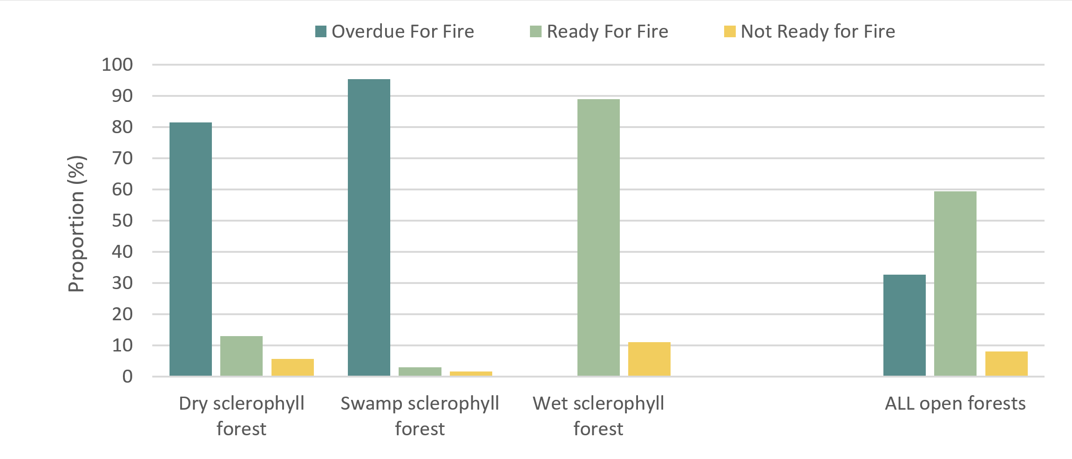
Figure 1. Fire interval status across all fire-dependent vegetation on the property. Overdue – current fire interval is longer than the recommended maximum; Ready for fire – the vegetation is now in the recommended window for burning; Not ready for fire – the vegetation is not yet within the window for burning. See Map 5.

Open-forest condition & access
Using the Open-forest Condition Classes table and Forest Health Indicators (See Good Fire – Healthy Country for assessment methods– Appendix B6), add a description, and map (replace example - Map 6) the broad condition of fire-dependant vegetation communities (good condition, moderate condition, poor condition, not suitable for Good Fire). This section should also outline any issues relating to condition (i.e. overabundant saplings and transformer weeds) as appropriate.
Fire exclusion and wildfires often change the structure and composition of open forest. Of the open forests suitable for the restoration of good fire, [XX%] is in good condition, [XX%] is in moderate condition and [XX%] is in poor condition (Map 6). Descriptions of condition classes on the property are given in Table 3.
Most areas in declining condition are [ready or overdue] for fire, and have a dense midstorey of invading rainforest pioneers, and localised areas of dense sclerophyll saplings (e.g. Eucalyptus, Syncarpia, Lophostemon, Melaleuca) and/or transformer weeds (e.g. Camphor Laurel). In these areas, heathy ground layer plants (e.g. Xanthorrhoea macronema, Lomatia silaifolia, Patersonia glabrata) are widespread in well-lit openings and track edges, but largely absent in the dense shade and litter beneath the saplings. This indicates that these forests previously supported a heathy ground layer, which is now being displaced by overabundant saplings. The ecological consequences of rainforest pioneer invasion are summarised in Figure 2.
Consistent with a conservation triage approach, areas that are in ‘good condition’ are the highest priority for action and should be secured from decline before moving into other areas. These areas offer the best return for effort using good fire alone. ‘Moderate condition’ areas are high-moderate priority but may require treatments additional to fire. Areas in ‘poor condition’ have relatively low resilience and should only be attempted once other areas have been restored.
Table 3. Condition of fire-dependent ecosystems across the property.
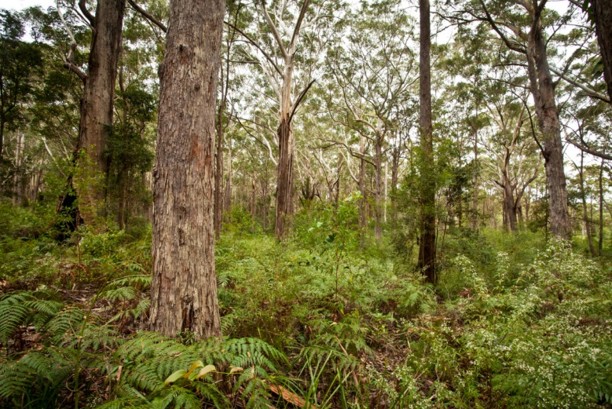
Good Condition
Area: 2 ha (5%)
Description: dry sclerophyll forest on ridgelines and north-facing slopes in western portion of property; swamp sclerophyll forest along eastern boundary.
Very sparse midstorey of mostly sclerophyll shrubs (e.g. Allocasuarina littoralis, Acacia longissima, Nematolepis squamea).
Dense ground layer of heathy shrubs and graminoids in dry sclerophyll forest (e.g. Zieria smithii, Podolobium ilicifolium, Xanthorrhoea macronema, Lomandra multiflora) and sedges/ferns in swamp sclerophyll forest (e.g. Gahnia sieberiana, Blechnum indicum).
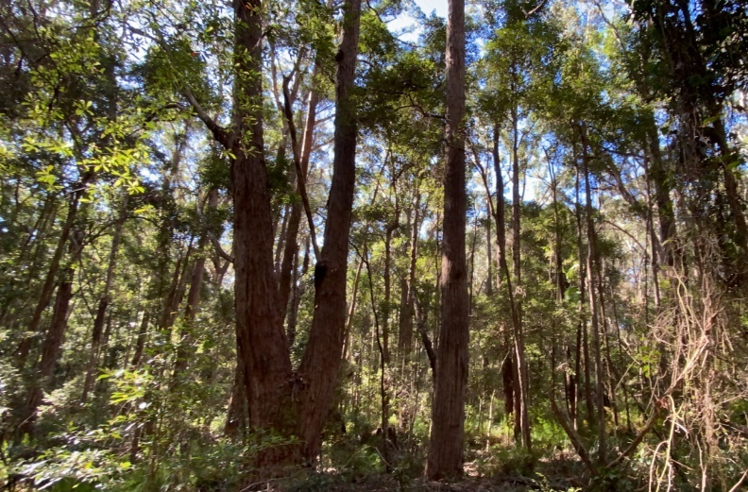
Moderate Condition
Area: 30 ha (75%)
Description: dry sclerophyll forest in south-western corner
Moderately dense midstorey of invading rainforest pioneers (e.g. Synoum glandulosum, Polyscias elegans, Macaranga tanarius) and fire-sensitive transformer weeds (e.g. Camphor) and high density of sclerophyll trees (e.g. Syncarpia glomulifera, Allocasuarina littoralis).
Sparse/patchy ground layer of scattered ferns (e.g. Pteridium esculentum, Calochlaena dubia), graminoids (e.g. Lomandra multiflora, L. longifolia) and occasional heathy shrubs (e.g. Austromyrtus dulcis, Lomatia silaifolia).
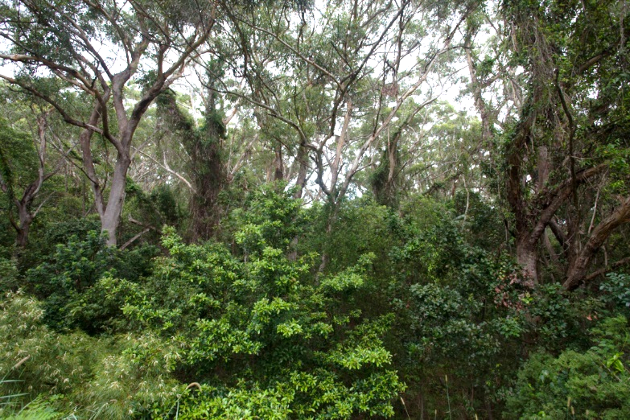
Poor Condition
Area: 8 ha (20%)
Description: dry sclerophyll forest on metasediments in eastern portion.
Dense midstorey of invading rainforest pioneers (e.g. Synoum glandulosum, Polyscias elegans, Macaranga tanarius).
Sparse ground layer of rainforest ground layer plants (e.g. Alpinia caerulea, Marsdenia rostrata) and seedlings / saplings (e.g. Synoum glandulosum, Cupaniopsis anacardioides, Guioa semiglauca).

Transformer weeds
Numerous weed species are favoured by fire-exclusion and have the potential to form a dense midstorey or canopy (e.g. Camphor Laurel, Umbrella Tree) that can displace open forest understorey plant communities and associated fauna habitat. At least [12] of the weeds known to occur on the property have a high potential to be transformer weeds that suppress ground layer habitat and flammability (Table 4). These weeds are a high priority for treatment on the property.
Table 4. Transformer weed species recorded on the property and likely to be favoured by low frequency fire.
Strata | Weed Species
Canopy trees | Camphor Laurel (Cinnamomum camphora)  Umbrella Tree (Schefflera actinophylla)
Midstorey | Cherry Guava (Psidium cattleianum)  Winter Senna (Senna pendula)  Wild Tobacco (Solanum mauritianum)
Scrambler or Climber | Common Passionfruit (Passiflora edulis)  Morning Glory (Ipomea indica)

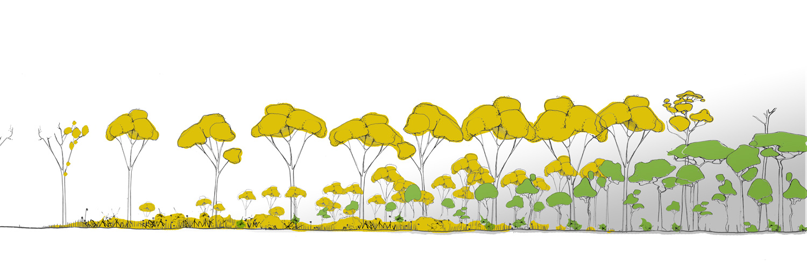

Early-stage
Late-stage
Negligible
Plants (open forest)
- canopy trees cannot recruit new seedlings in shade
- premature dieback of canopy trees from: altered soil chemistry, soil microbes, competition for nutrients & water, and/or Bell Miner Associated Dieback
Animals (open forest):
- loss of fauna dependent on hollows, nectar and foliage of open forest canopy trees

Plants (open forest)
- understorey plants decline in deep shade
- understorey plants cannot recruit new seedlings in shade
Animals (open forest)
- understorey animals decline without forage, shelter and nesting resources previously provided by dense understorey plants
- midstorey flying animals decline without room to move beneath canopy
Plants (open forest)
- understorey plants thrive in high light, suitable soil chemistry and soil microbial conditions
- understorey and canopy flora recruit new seedlings after fire
- canopy trees thrive with suitable soil chemistry, microbial conditions and adequate soil water
- canopy trees not affected by Bell Miner Dieback without dense midstorey nesting habitat
Animals (open forest)
- understorey animals have abundant forage, shelter and nesting resources in dense understorey
- midstorey flying animals have ample room to move beneath canopy
- canopy animals have abundant hollows, nectar and foliage of open forest canopy trees
Increasing Rainforest Invasion

Figure 2. A summary of ecological consequences of rainforest invasion on open forest biodiversity.

Cultural issues
Provide a brief text description that identifies cultural issues relating to the current fire regime on the property. This section should identify which cultural values at risk from the changed fire regime and how.
The brief cultural survey of the property found several aboriginal values were declining due to the loss of Aboriginal fire regimes. Due to the lack of fire in the grassy Eucalypt forests on the western side of the property, shrubs and young trees have become thick and overgrown in many areas, leading to the loss of important grassy pathways (Figure 3, Figure 1, Map 4) and the decline of the culturally important honeysuckle trees (Banksia species). The north eastern corner of the property is at risk from high intensity wildfire, which threatens the large, old-growth scar trees along the ridgeline (Figure 3), and the adjacent rainforest gully and its associated culturally significant species.
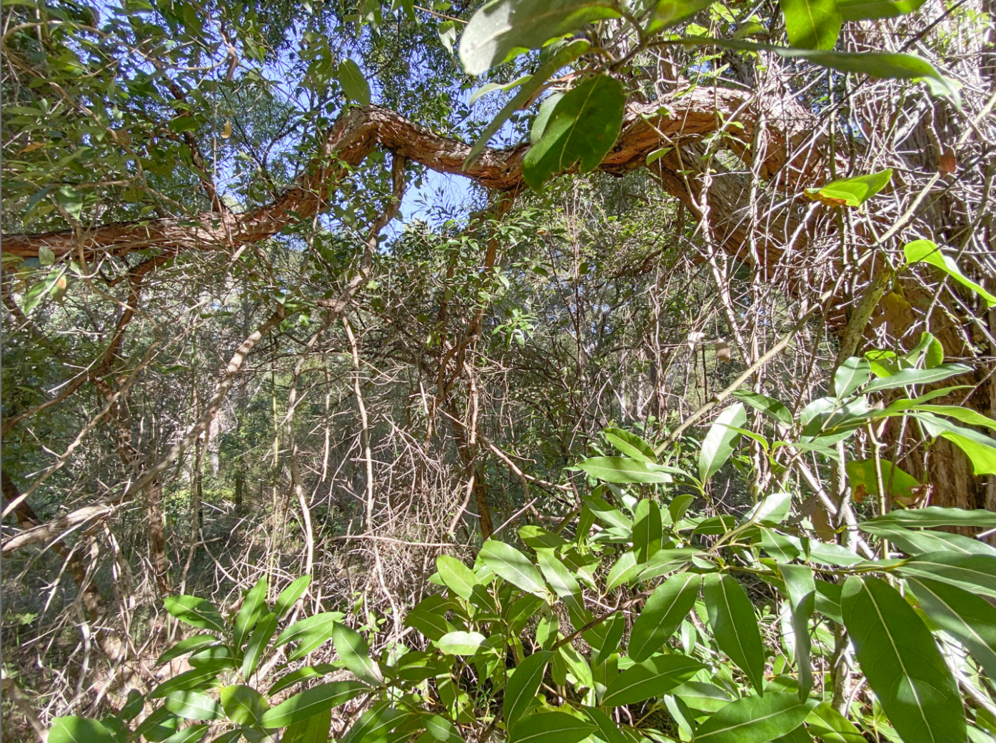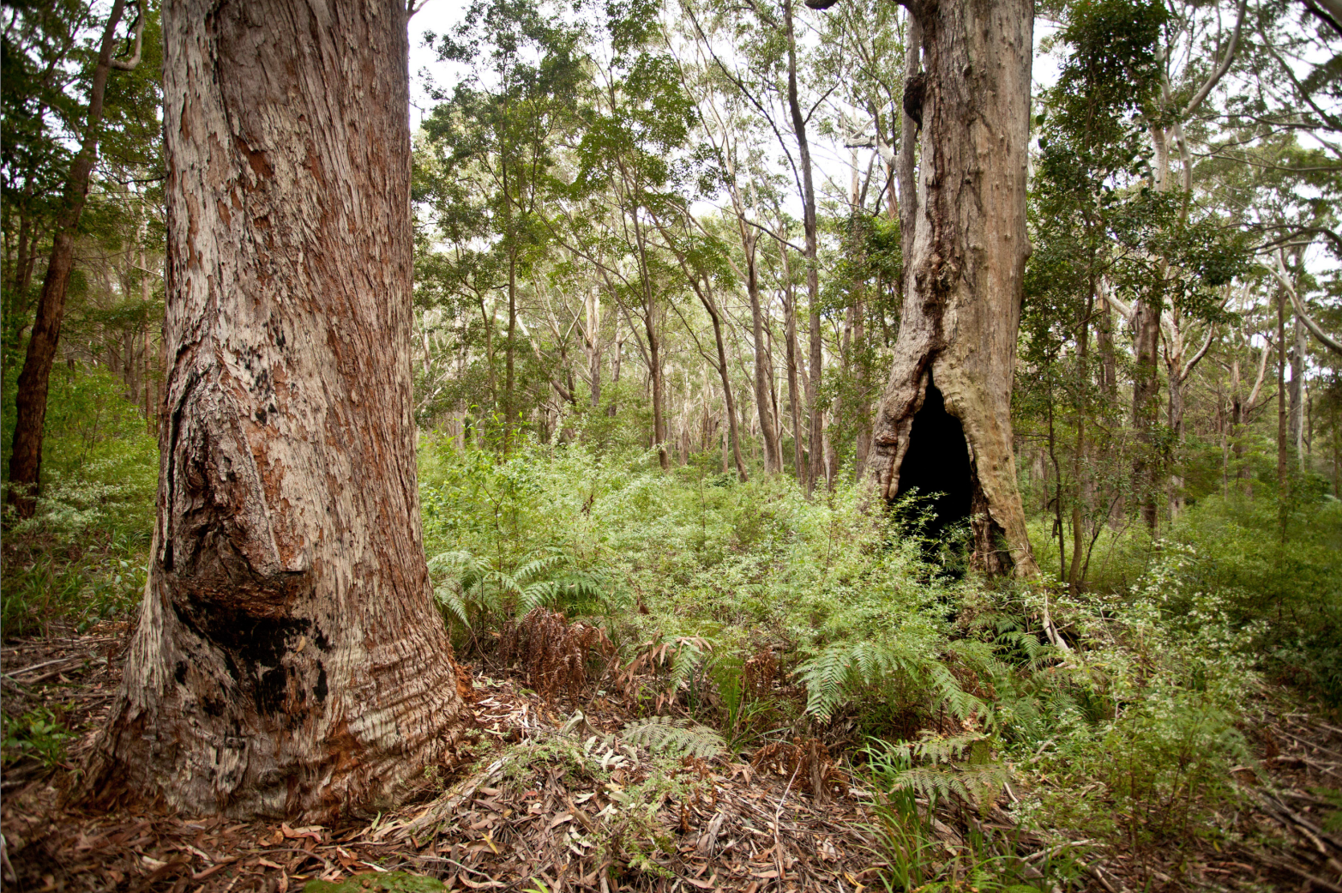
Figure 3. Examples of cultural values declining, or at risk, due to the loss of Aboriginal fire regimes, including overgrown grassy pathways (left) and old-growth scar trees at risk from high severity wildfires from the heathland on the neighbouring Reserve. .

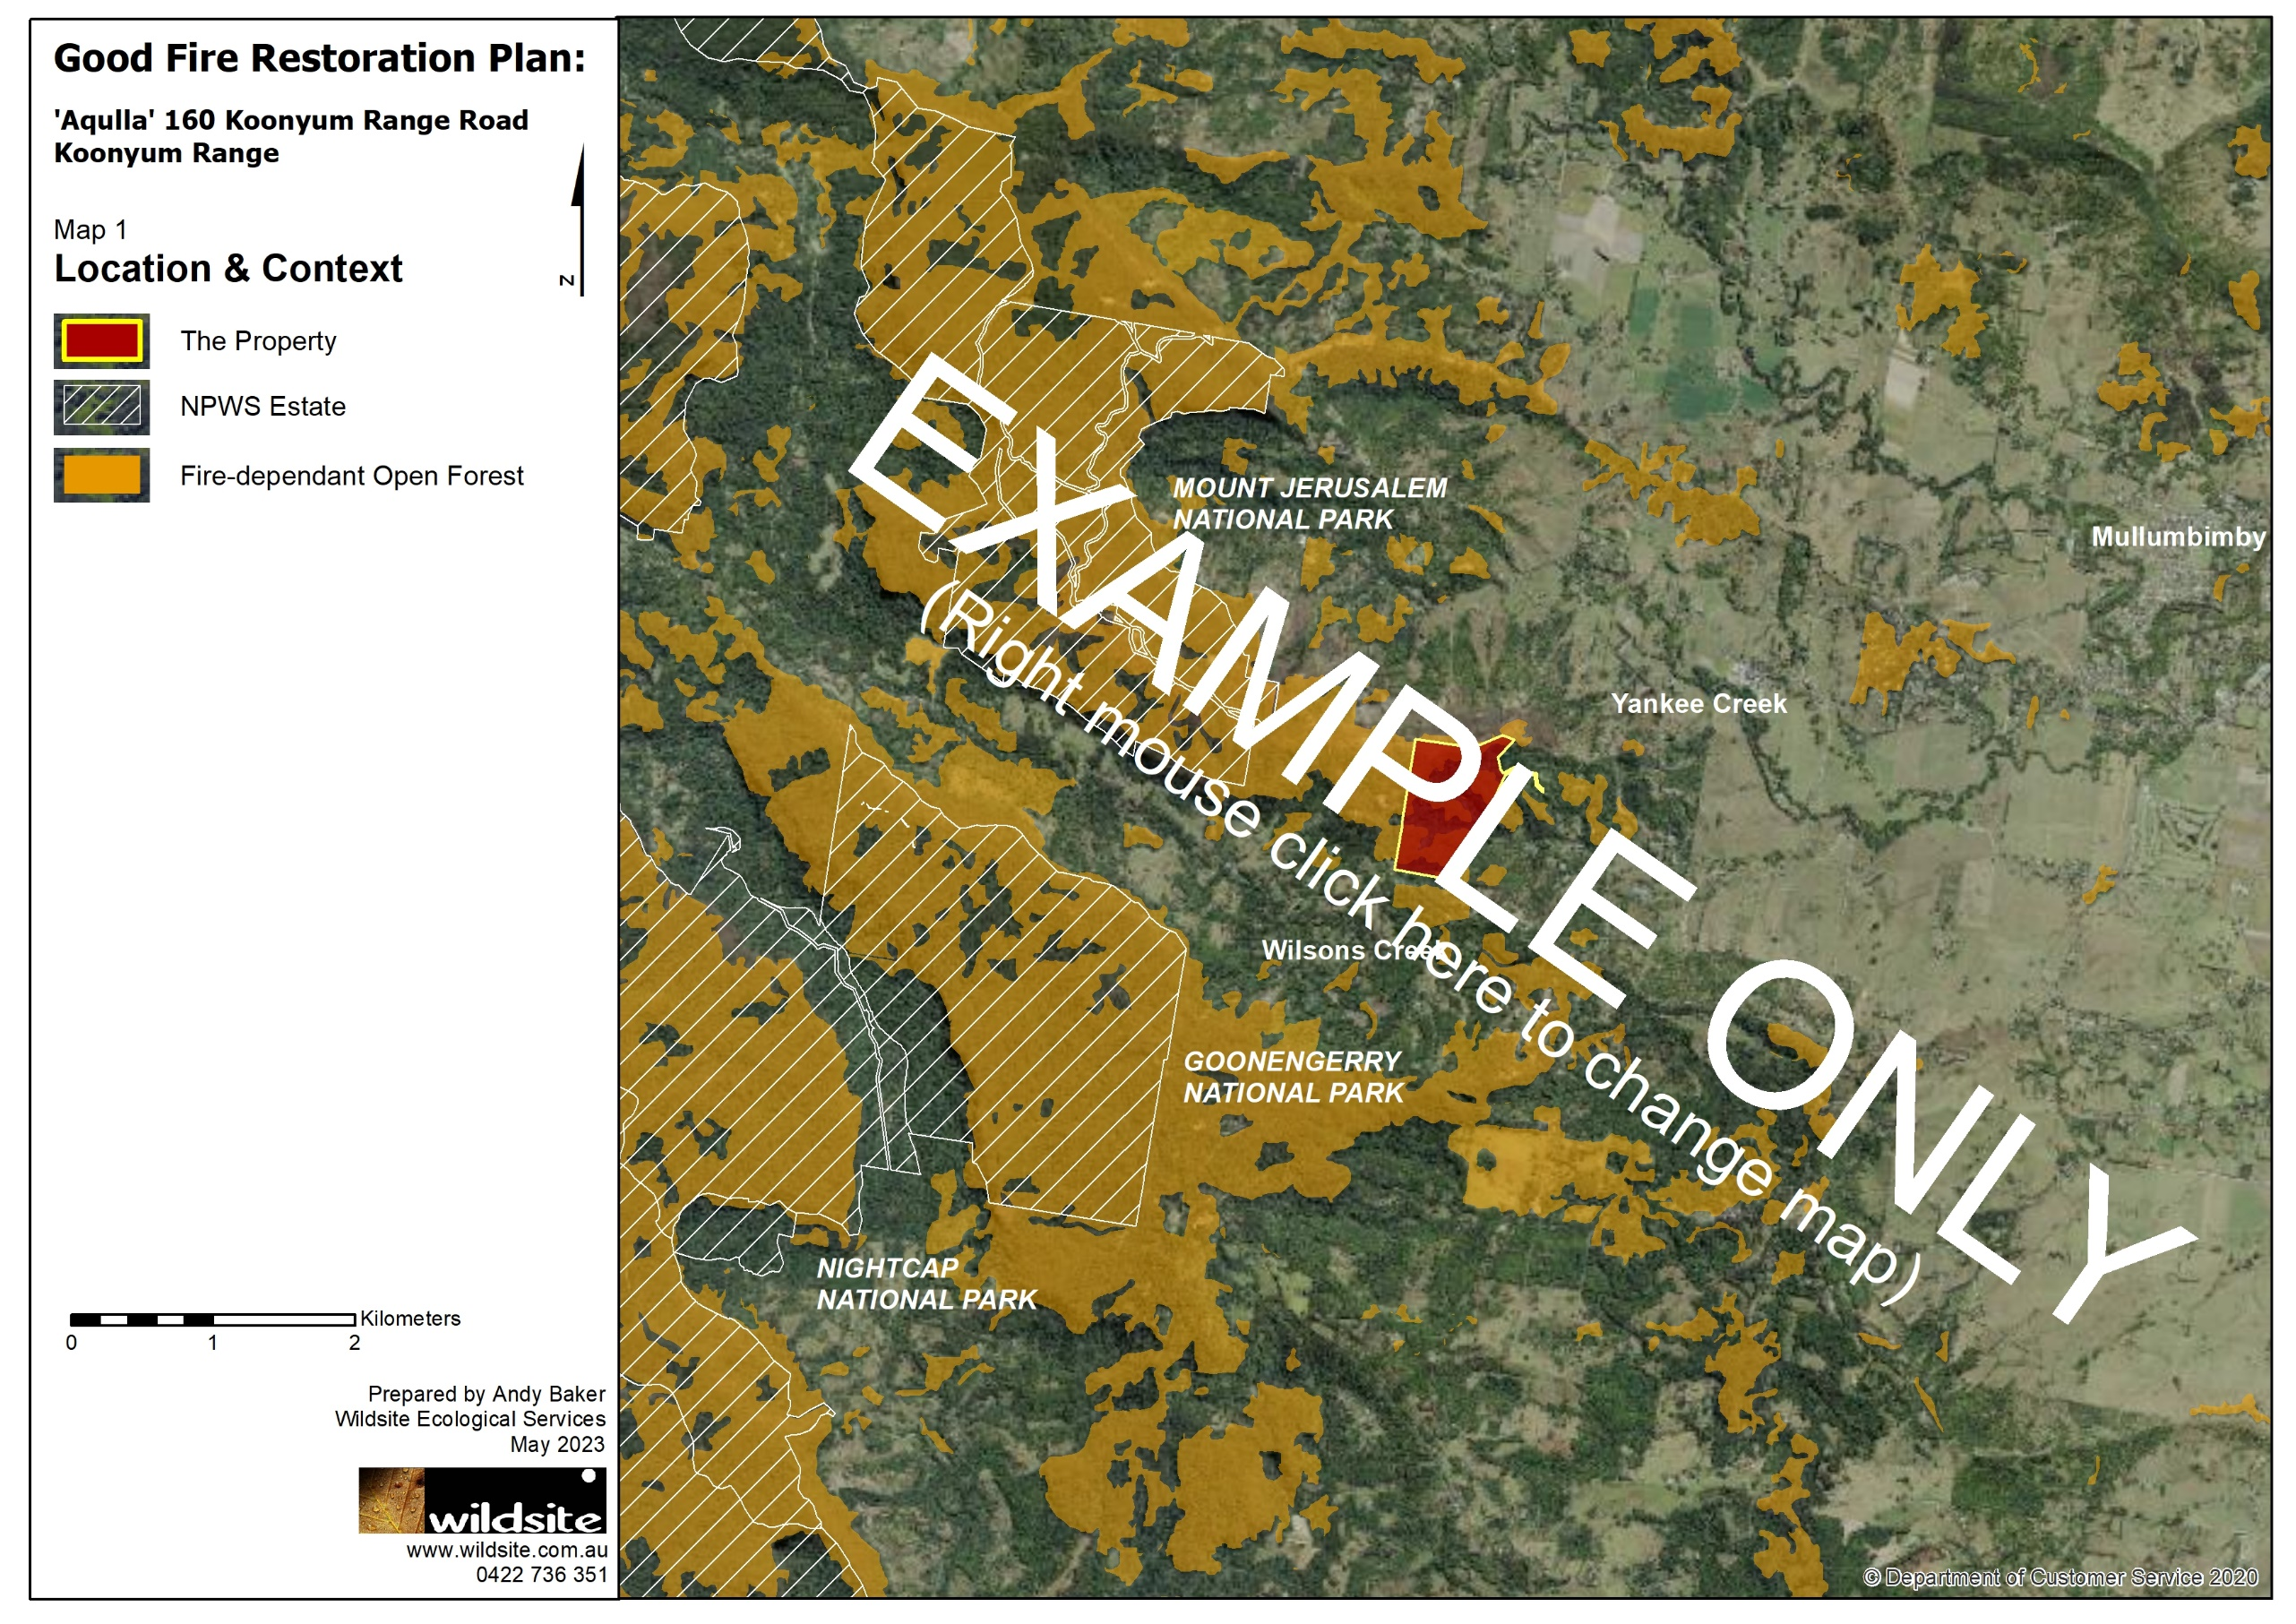
Maps
Map 1. Location and Context

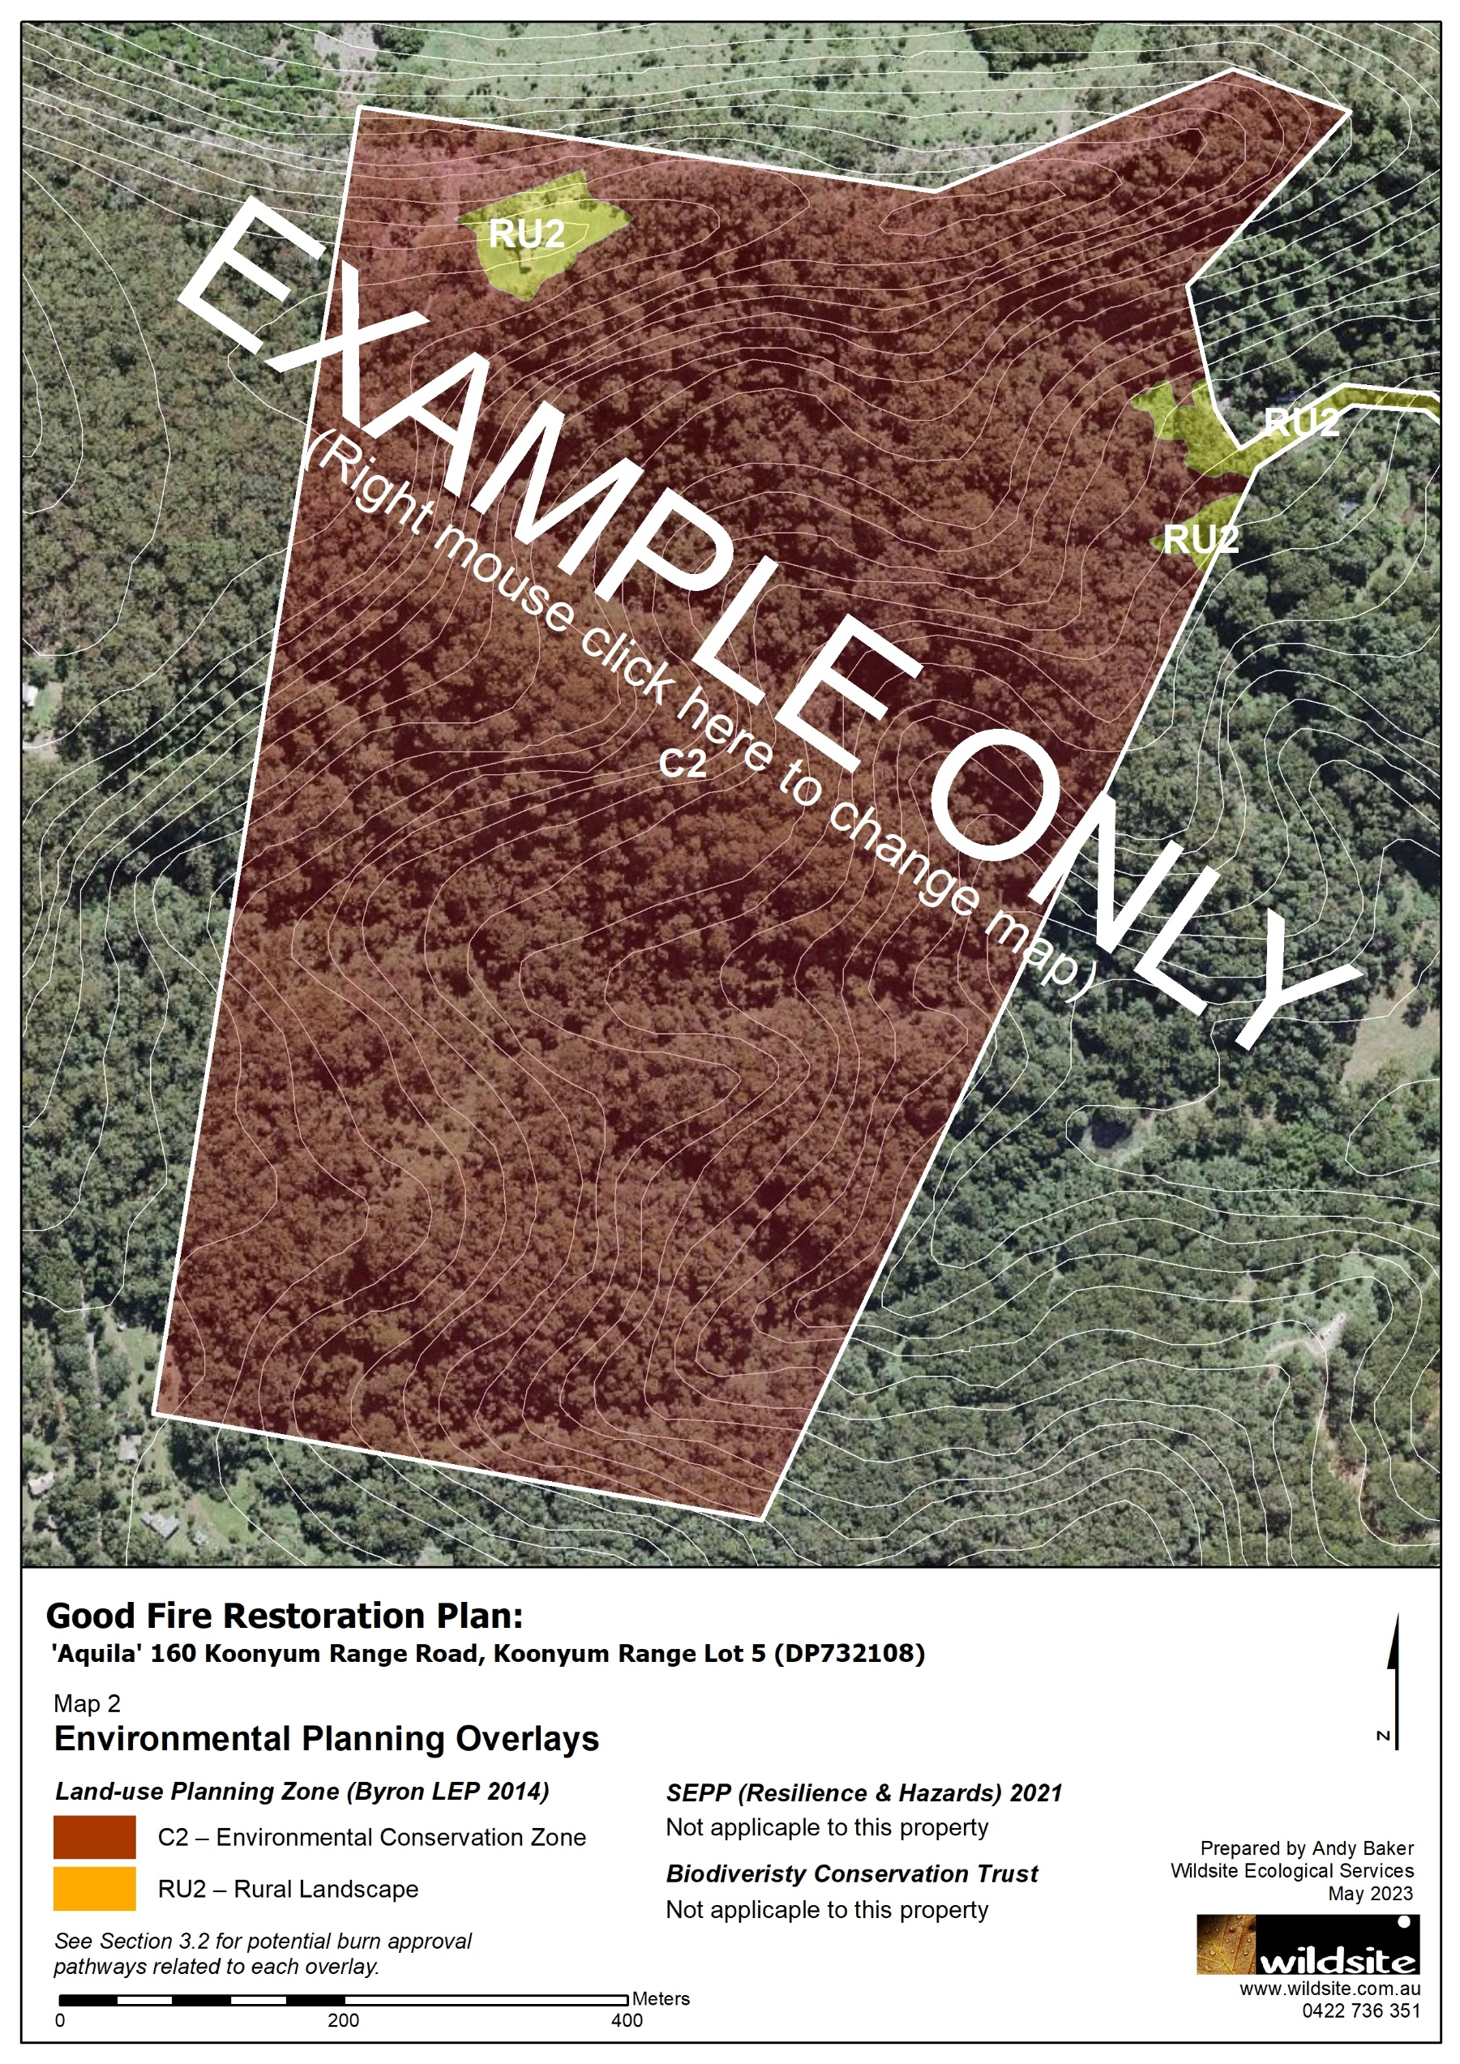
Map 2. Environmental Planning Overlays.

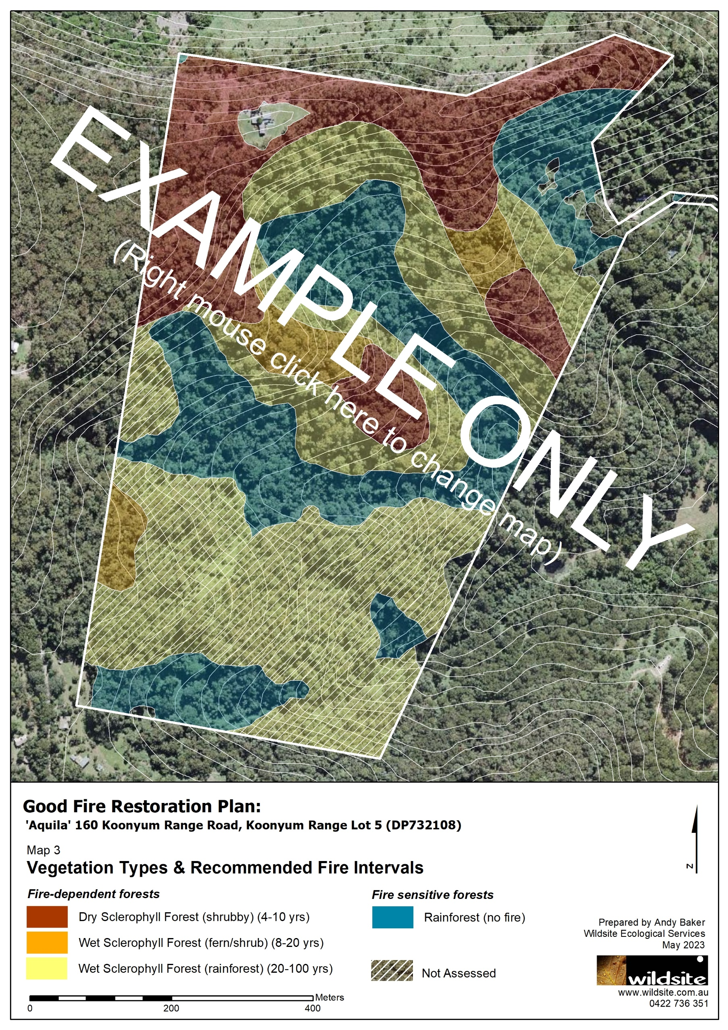
Map 3. Vegetation Types & Recommended Fire Intervals

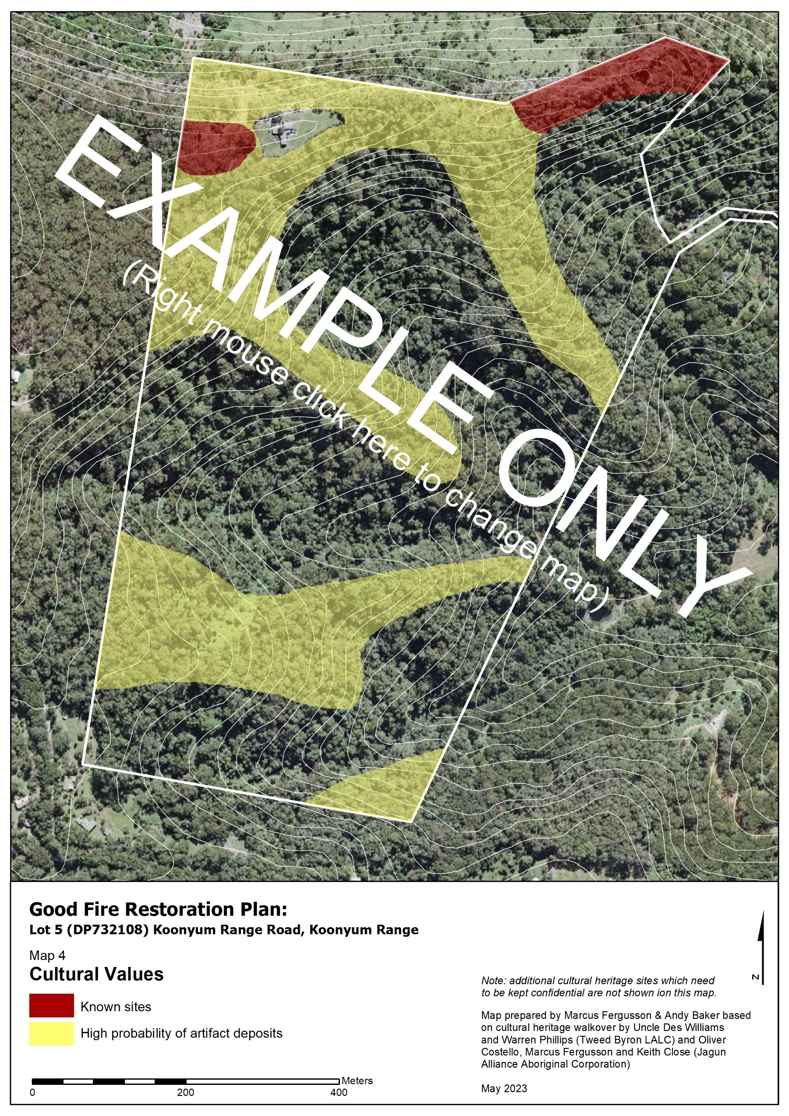
Map 4. Cultural Values

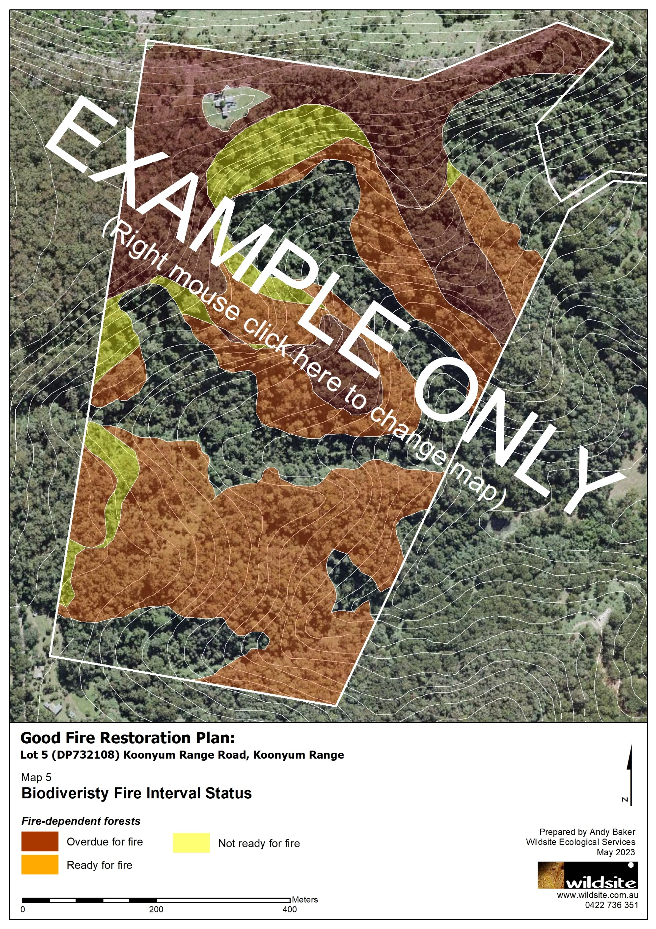
Map 5. Biodiversity Fire Interval Status

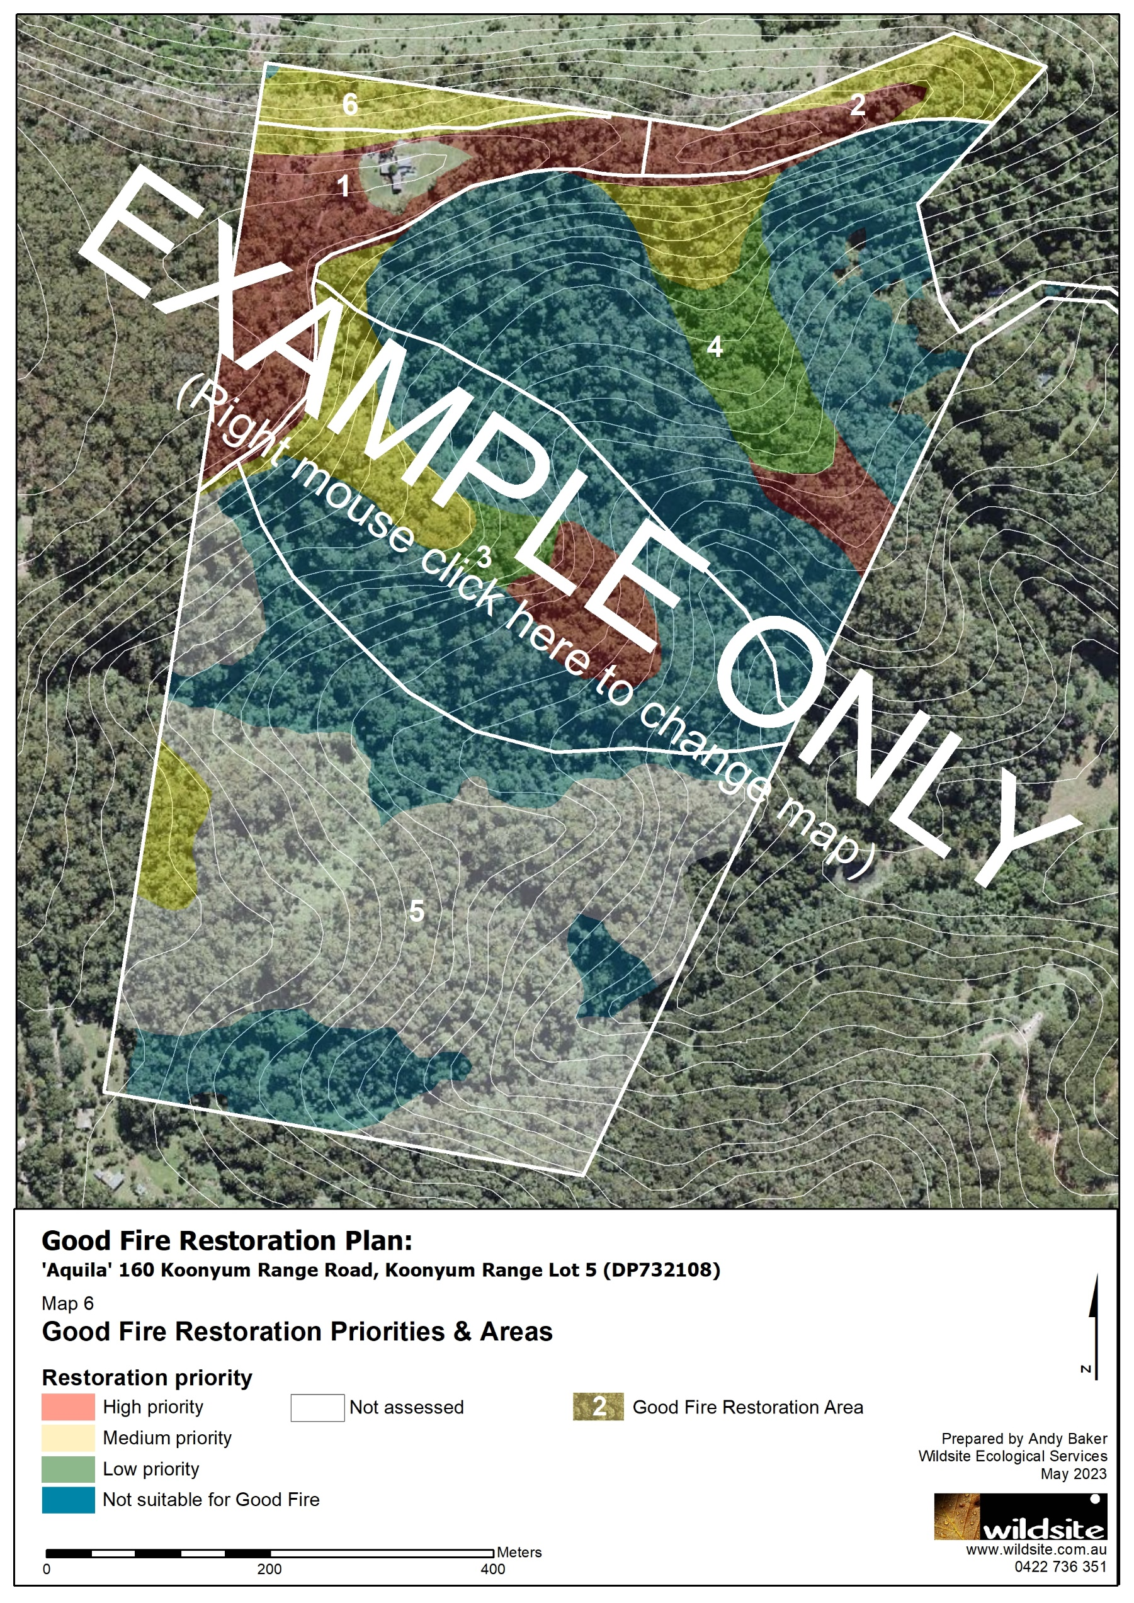
Map 6. Open-forest Condition & Good Fire Restoration Areas.

Good Fire Guidelines
The guidelines below are to be included in all Good Fire Restoration Plans and should only be removed or modified if your property has special circumstances.

Guidelines for property-wide burn program
This section provides key guidelines for the property-wide implementation of the Good Fire Restoration program outlined by this plan. For more information on the rationale behind these guidelines, see the Good Fire – Healthy Country document. Operational guidelines for individual burns are given in section 7.2 below.
RESTORING APPROPRIATE FIRE INTERVALS
- The program will be guided by the fire intervals of the ‘Planned Burn Guidelines: Southeast Queensland Bioregion’ (Map 3) and field assessment of target structure and composition (see below).
- Fire intervals may be modified in localised areas to maintain culturally significant sites or where forest condition indicators suggest premature decline (e.g. overabundant saplings).
- In previously long-unburnt open forest, the interval between the first and second burn should use the minimum recommended interval (e.g. 4 years - shrubby dry sclerophyll forest) to help manage the legacy effects of fire-exclusion.
RESTORING APPROPRIATE STRUCTURE & COMPOSITION
- In dry sclerophyll forest, swamp sclerophyll forest, and grassy/fern/shrub wet sclerophyll forest, restoration should aim for:
  - an open canopy (<70% crown cover), an open-sparse midstorey (<40%) and a dense ground layer (> 25% crown cover).
  - ground layer communities dominated by shade-intolerant graminoids, heathy shrubs, forbs and/or ferns consistent with the forest type.
- Wet sclerophyll forest with a rainforest subcanopy are not suitable for planned burns, but will ideally be restored/maintained by periodic wildfires (20-100 years).
PRIORITISING BURN AREAS
- Burns are to be prioritised using a triage approach that prioritises areas in good condition and the highest return for restoration effort. Using Map 6, burns are to be prioritised as follows:
- ‘good condition’ areas are very high priority and should be secured from decline before moving into other areas.
- ‘moderate condition’ areas are high-moderate priority, that should be treated after first securing good condition areas, or opportunistically with appropriate weather conditions (e.g. when good condition areas are too dry).
- ‘poor condition’ areas should only be attempted once all other areas have been restored, or if they have high cultural or ecological value (e.g. provide a crucial corridor for koala movement).
- Planned burns will aim for a mosaic of different age classes (time since fire) across the property, by i) staging the initial reintroduction of fire across the property over 10 years, and ii) in a given year, spreading burns widely across the property and restoration areas (Map 6).
- Burn sequencing must ensure at least 50% of Allocasuarina littoralis stands in the locality are at least 3-years old (i.e. fruiting age) to maintain forage for Glossy Black Cockatoos.
- Annual implementation of priority burns is to be guided by an Annual Action Plan (Appendix B).
ACCESS AND FIRE MITIGATION (MAINTAIN ROADS, TRAILS AND CONTROL LINES)
- As required monitor and maintain roads, access tracks and fire breaks to provide access and containment.
- Asset Protection Zone (APZ) – maintain low fuel loads around built assets - Regularly slash/clear in particular before and during the Bush Fire Danger Period.
MONITORING & ADAPTIVE MANAGEMENT
- The Plan adopts an adaptive management approach that involves implementing, monitoring, reporting and revising actions and outcomes to learn which actions are most effective at achieving specified objectives.
- Monitoring will follow the guidelines included in Appendix C.

Operational guidelines for individual burns
The following guidelines are to be used as a checklist for the implementation of individual burns.
ITEM | OPERATIONAL GUIDELINES
Burn Plan | Individual burn plans are to be prepared for all burns using the template in Appendix D.
Approval, Permits & Notifications | Ensure appropriate approvals, permits and notifications are in place prior to each burn.
Containment Lines | Brief all personnel involved with containment line establishment on cultural and ecological values to be avoided.  Assist postfire regeneration of containment line by, a) brush cutting or slashing no earlier than 2 weeks before a burn and b) closing all access immediately after the burn.
Burn Timing | Burns should only be conducted during periods of good soil moisture to support post-fire regeneration.  Where possible, stagger multiple ignitions across the season within a zone, to increase habitat patchiness and extend the period of the flowering and seeding time of grasses and herbs.
Aboriginal Cultural Heritage | Seek advice from cultural knowledge custodians on appropriate protocols to protect and enhance Aboriginal Cultural Heritage. Protect sensitive items from flame and radiant heat by raking, leaf blowing or wetting down surface fuels adjacent to the site.  All personnel involved in burn implementation are to be briefed on culturally sensitive locations and required safeguards.  Inspect all old growth trees before cutting, falling or burning to ensure there are no Cultural modifications (scars or engravings), wildlife hollows or exposed dead wood at the base that might catch fire.  Avoid or remediate earthworks disturbance.  It is recommended traditional custodians be present for the duration of all burns.
Culturally significant species and habitat | Avoid bushfire in Rainforest  Maintain healthy grassy forest and pathways to allow access and to provide habitat for culturally significant species  Maintain open country with grasses, seeds and fruits for insects, birds and mammals.  Protect mature wattle trees as they have an important role and provide resources, but as there are too many we need to maintain a balance with other plant species, so wish to clear some young wattle.  Protect and/or rejuvenate Geebung and flowering nectar plants, some will get burnt, but others will come back.  Protect and enhance Forest Oak (Allocasuarina torulosa) feed trees for Gehrrl (Glossary Black-Cockatoo)  Protect mature (parent) canopy trees, which provide important roles, habitat and resources like blossoms for Wijoon (sugar glider, squirrel glider and yellow-bellied glider)  Protect and enhance habitat trees, as they are the home of culturally important species like Owls, possums and birds.
European Heritage | Protect sensitive items from flame and radiant heat by raking, leaf blowing or wetting down surface fuels adjacent to the site.  All personnel involved in burn implementation are to be briefed on sensitive locations and required safeguards.
Threatened Fauna | Identify koala risk areas (low canopy and/or tall heathy understorey) and mitigate risk by pre-burn koala search, pre-burn site preparation and strategic burn tactics  Rake away, or wet down, fuels around hollow-bearing trees, active koala trees, dead stags, and fallen logs.  All personnel involved in burn implementation are to be briefed on sensitive features and required safeguards.
Threatened Flora | Undertake pre-burn search for threatened rainforest plants in wet sclerophyll forest burns; and rake away, or wet down fuels, around any identified individuals.  Protect fire-sensitive rainforest vegetation using containment lines, fuel moisture differences or appropriate burn tactics.  All personnel involved in burn implementation are to be briefed on sensitive features and required safeguards.
Environmental Weeds | Undertake pre- and postburn control of environmental weeds for all burns.
Peat Soils | Ensure peat soils (swamp forest or wet heath) are either waterlogged or inundated prior to burning.
Smoke Management | Avoid weather conditions that will carry smoke towards smoke-sensitive areas.  If smoke becomes a hazard on local roads or highways, the police and relevant media (e.g. local radio) must be notified.

Guidelines for Aboriginal cultural values
- If any known or potential Aboriginal Cultural values are identified on the property, it is requested that local Traditional Custodians are informed.
- Approval should be sort from Traditional custodians before including or sharing any sensitive cultural information, locations and imagery.
- Many heritage sites of significance and cultural heritage may need to be kept confidential to maintain cultural protocols or protect values from potential harm.

Action Table
This section identifies actions required to achieve the Plan objectives. Non-italicised actions should be retained for all plans and edited where necessary. Italicised actions provide examples only and should be adapted or deleted according to the specific property.
This section identifies what is needed to realise the vision and objectives of this Plan over the next 10 years. Actions have been prioritised as: VERY HIGH priorities within 1-2 years; HIGH priorities within 3 years; MEDIUM priorities within 5 years; LOW priorities within 10 years; ONGOING priorities are to be completed annually or as specified.
ID | GOOD FIRE RESTORATION AREAS (RA) | RECOMMENDED ACTIONS | PRIORITY | PERFORMANCE INDICATOR
1 | All RAs | Annual burn planning (property-wide): During the bushfire danger period (i.e. November-March) each year, carry out property-wide annual burn planning to: a) identify and map targeted burn areas for the upcoming year, b) identify areas that require baseline (preburn) or are due for postburn monitoring (See Appendix C). | Ongoing | Annual Burn Plans completed by start of planned burn season
2 | All RAs | Annual burn planning (individual burns): Following identification of all areas targeted for burning in that year (Action 1), each burn area is to have an individual burn plan prepared in accordance with Appendix D. | Ongoing | Individual burn plans completed prior to burns.
2 | All RAs | Annual burn implementation: Implement annual burn program (prepared burn plans) during the appropriate burn season. | Ongoing | Annual burns implemented by end of burn season.
3 | All Ras | Access and fire containment: Before the bushfire danger period each year survey condition of existing fire trails and fire containment opportunities on the property; identify trails as either Dormant, Important or Essential to provide clear reference for NSW Rural Fire Service (RFS) for Wildfire Response.  Protect fire-sensitive attributes and cultural values, including scar trees, rock art and habitat trees. | Very High | Fire trails and containment opportunities identified throughout property.
4 | All RAs | Investigate opportunities to work with property neighbours (private and agency-managed) to restore good fire across boundaries. | Very High | Opportunities to work with neighbours identified.
5 | All RAs | In year five (20##) and year ten (20##) of the Plan, collate and analyse monitoring data to determine the effect of fire on: midstorey cover; ground layer cover and composition. The findings are to be written up into a brief monitoring report, which includes recommendations for improvements to the burning program. | Ongoing | Monitoring data analysed and reported.
6 | RA 1  Example text: Buruubii -  Koala | Example text. Remove transformer weeds (Table 4) throughout RA. | High | Transformer weeds removed.
7 | RA 1  Example text: Buruubii -  Koala | Example text. Connect fire trails on western side of RA near scar tree. | High | Fire trails connected
8 | RA 3  Gwaabil –  Grass | Example text. Collect seed and propagate native grass for postfire planting. | Moderate | Grasses ready for planting
9 | RA 3  Gwaabil –  Grass | Example text. Manually clear and maintain cultural sites | High | Cultural site maintained

Acknowledgements and Disclaimer
This Good Fire Restoration Plan has been prepared by [insert contractor / lead agency]. This plan has been prepared with input from and in consultation with a range of stakeholders, including: [#######].
The information in this document is general in nature and is intended as a guide only. The information is not designed to be, nor should it be, regarded as advice on bush fire risk mitigation, burn implementation (including legal requirements for implementing a burn) or hazard reduction activities, or any other advice.
The plan relies upon data and information that was current at the time of preparing this plan. The authors do not warrant or represent that the information in this guide is free from errors or omission, or that it is exhaustive. Although the authors have compiled this information in good faith, exercising all due care and attention, no representation is made about the accuracy, completeness, reliability or suitability of the information for any particular purpose.
The authors will not accept liability for any loss, damage, cost or expense incurred by any person or organisation using or relying on the information in this guide. By accessing and using this guide, readers acknowledge that they are responsible for making their own assessment of the information and its relevance.

Appendices
Appendix A. Fire-habitat relationship of threatened species known or likely to occur on the property.
Table A1. Fire-dependent ecological values. BC – NSW Biodiversity Conservation Act, EPBC – C’wlth Environment Protection & Biodiversity Conservation Act, EEC – Endangered Ecological Community, E – Endangered, V – Vulnerable.
Conservation Value | BC | EPBC | Fire-dependent Habitat Association¹
High Conservation Value Vegetation
Dry Sclerophyll Forest of the NSW Far North Coast | EEC² |  | Dry sclerophyll forest
Threatened Flora
Giant Spear Lily (Doryanthes palmeri) | V |  | Rocky outcrops in montane heath.
Nightcap Plectranthus (Plectranthus nitidus) | E1 | E | Open rocky areas near forest.
Hartman's Sarcochilus (Sarcochilus hartmannii) | V | V | Rocky outcrops in eucalypt forest and occasionally at the bases of fibrous trunks of trees, including cycads and grass-trees.  EXAMPLE TABLE ONLY  (Complete table with species relevant to the property)
Threatened Fauna
Glossy Black-Cockatoo (Calyptorhynchus lathami) | V | V | Open forest and woodlands. Feeds almost exclusively on the she-oak seeds. Nests in large hollow-bearing eucalypts.
Masked Owl (Tyto novaehollandiae) | V |  | Dry eucalypt forests and woodlands. Roosts and nests in large eucalypt hollows.
Large-eared Pied Bat (Chalinolobus dwyeri) | V | V | Dry open forest and woodland. Foraging for small, flying insects below the forest canopy.
Greater Glider (Petauroides volans) | E1 | E | Largely restricted to eucalypt forests and woodlands. Folivorous diet of eucalypt leaves and occasionally flowers. Nests in large Eucalypt hollows.
Koala (Phascolarctos cinereus) | E1 | E | Open eucalypt forest and woodland.
New Holland Mouse (Pseudomys novaehollandiae) |  | V | Heathlands, woodlands and open forests with a heathland understorey. Prefers early to mid-stages of postfire succession.
- Unless specified, habitat associations are sourced from DPE threatened species profiles (https://www.environment.nsw.gov.au/threatenedspeciesapp/).
- All areas of dry sclerophyll forest on the property are consistent with the candidate EEC ‘Dry Sclerophyll Forest of the NSW far North Coast’ for which a nomination for listing under the BC Act is currently being prepared.
Table A2. Fire-sensitive ecological values. BC – NSW Biodiversity Conservation Act, EPBC – C’wlth Environment Protection & Biodiversity Conservation Act, EEC – Endangered Ecological Community, E – Endangered, V – Vulnerable.
Conservation Value | BC | EPBC |  | Fire-sensitive Habitat Association¹
High Conservation Value Vegetation
Lowland Rainforest | EEC | EEC | Rainforest
Threatened Flora
EXAMPLE TABLE ONLY
(Complete table with species relevant to the property)
Arrow-head Vine (Tinospora tinosporoides) | V |  | Rainforest and ecotones
Green-leaved Rose Walnut (Endiandra muelleri subsp. bracteata) | E1 |  | Rainforest and ecotones
Peach Myrtle (Uromyrtus australis) | E1 | E | Rainforest and ecotones
Ravine Orchid (Sarcochilus fitzgeraldii) | V | V | Rainforest and ecotones
Rusty Rose Walnut (Endiandra hayesii) | V | V | Rainforest and ecotones
Small-leaved Hazelwood (Symplocos baeuerlenii) | V | V | Rainforest and ecotones
Small-leaved Tamarind (Diploglottis campbellii) | E1 | E | Rainforest and ecotones
Threatened Fauna
Southern Pink Underwing Moth (Phyllodes imperialis southern subspecies) | E1 | E | Rainforest
Superb Fruit-Dove (Ptilinopus superbus) | V |  | Rainforest and ecotones
- Unless specified, habitat associated data are sourced from DPE threatened species profiles (https://www.environment.nsw.gov.au/threatenedspeciesapp/).

Table A3. Fire-variable ecological values. BC – NSW Biodiversity Conservation Act, EPBC – C’wlth Environment Protection & Biodiversity Conservation Act, EEC – Endangered Ecological Community, E – Endangered, V – Vulnerable.
Conservation Value | BC | EPBC | Fire-dependent/sensitive/variable Habitat Associations¹
Threatened Flora
Corokia (Corokia whiteana) | V | V |  | Boundaries between wet eucalypt forest and rainforest.
Davidson's Plum (Davidsonia jerseyana) | E1 | E |  | Rainforest and wet eucalypt forest.
Red Boppel Nut (Hicksbeachia pinnatifolia) | V | V |  | Rainforest, moist eucalypt forest and Brush Box forest.
Scrub Turpentine (Rhodamnia rubescens) | E4A | CE |  | Rainforest and wet eucalypt forest.
Threatened Fauna
EXAMPLE TABLE ONLY
(Complete table with species relevant to the property)
Common Planigale (Planigale maculata) | V |  |  | Rainforest, sclerophyll forests, heathlands, grasslands - preferring dense ground layer close to water.
Grey-headed Flying-fox (Pteropus poliocephalus) | V | V |  | Rainforests, open forests, woodlands, Melaleuca swamps and Banksia woodland. Canopy-feeding frugivore, blossom-eater and nectarivore.
Long-nosed Potoroo (Potorous tridactylus) | V | V |  | Coastal heaths, dry and wet sclerophyll forests and rainforests. Dense understorey with occasional open areas is essential part of habitat, and may include grass-trees, sedges, ferns or heath, or of low shrubs of tea-trees or melaleucas.
Sooty Owl (Tyto tenebricosa) | V |  |  | Rainforests and moist eucalypt forests. Nest in very large eucalypt tree-hollows.
Spotted-tailed Quoll (Dasyurus maculatus) | V | E |  | Eucalypt forests, rainforest and coastal heathy-woodlands. Prefers dense understorey and shrub layer.
Superb Fruit-Dove (Ptilinopus superbus) | V |  |  | Rainforest, moist eucalypt forest and swamp forest with fruiting rainforest trees in the understorey.
Yellow-bellied Sheathtail-bat (Saccolaimus flaviventris) | V |  |  | Forages over the canopy (rainforest, open forests) and treeless areas. Roosts in tree hollows, buildings and mammal burros (treeless ecosystems).
- Unless specified habitat associated data are sourced from DPIE threatened species profiles (https://www.environment.nsw.gov.au/threatenedspeciesapp/).

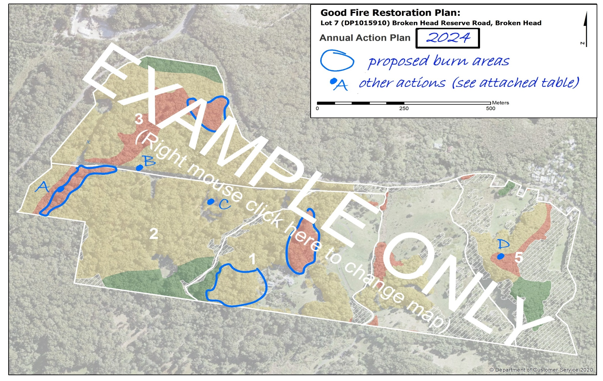
Appendix B. Example map and table for annual burn planning.

Action Table for 2024 page 1 of 2
ID | Action | Notes
A | Slash access track prior to burn | Aim to slash 1-2 weeks before burn
B | Undertake pre-burn monitoring
C | treat Camphor Laurel in preparation for future burn
D | re-establish old track to improve access

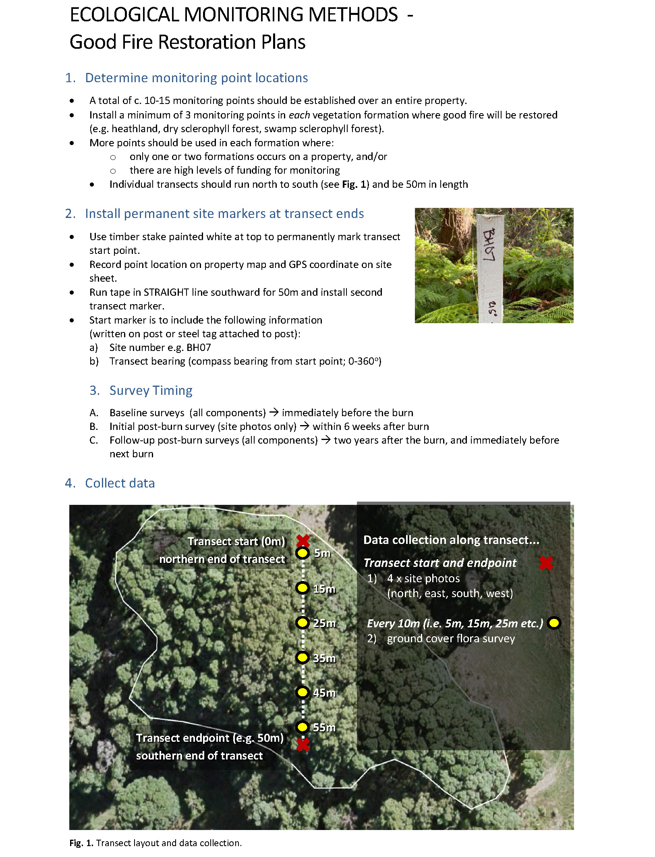
Appendix C. Monitoring Details

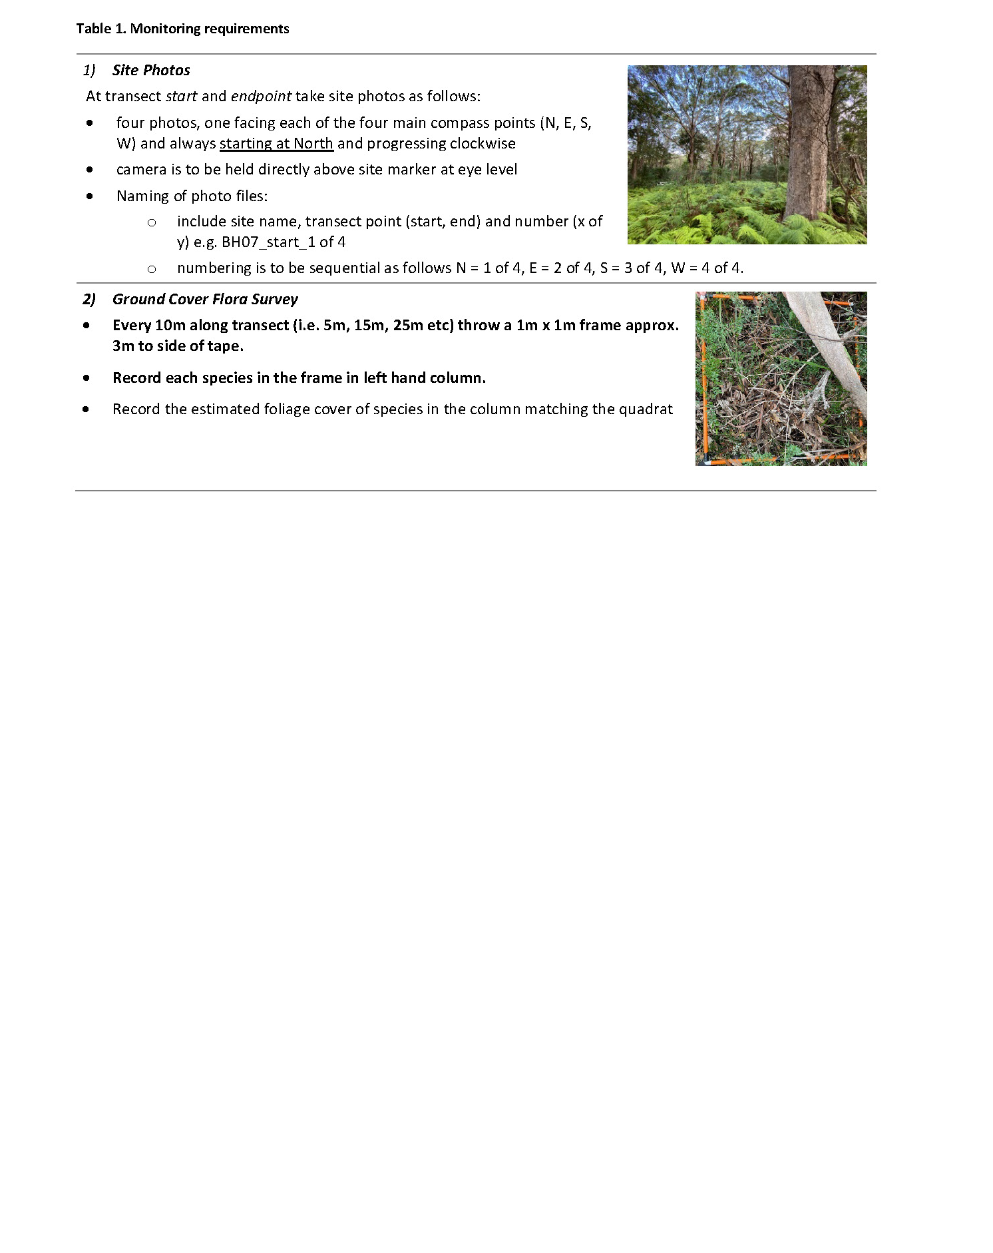
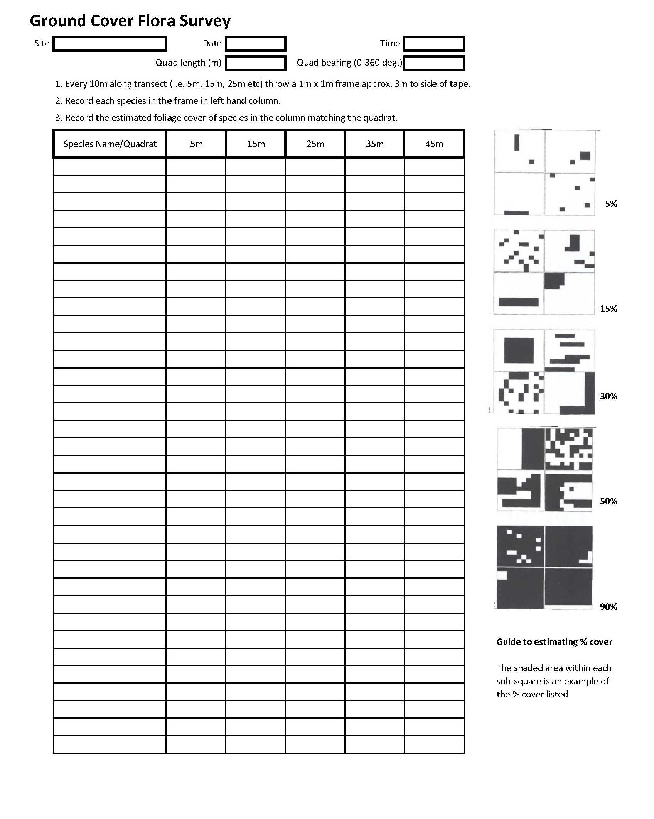

Appendix D. Burn Plan
Good Fire Restoration - Burn Plan

Introduction
Burn plans are a critical component of any eco-cultural burn. The purpose of a burn plan is to clearly detail all of the aspects of a prescribed burn to provide safety for those undertaking the burn and the wider community.
A good burn plan has a description of the burn area, target weather conditions, hazards that may be encountered, personnel needs and safety, and contacts to make prior to burning.
This Appendix is in two parts. Part A provides a brief outline of the different burn plan sections and guidelines to complete a burn plan. Part B is the actual burn plan template, which must be completed for each individual burn conducted over the duration of this restoration plan. However, not every section will be applicable to every burn. Each specific prescribed burn will have its own plan that is made up of only relevant sections and information.
The template plan includes several components including:
- goals and objectives of the burn,
- burn site description,
- fire prescription, operation, control, and post-burn requirements.

Part A – Completing a Burn Plan

Location and Owner Information, Emergency Contacts and Objectives.
The purpose of this section is to capture who owns the land, where the burn is taking place and the immediate contacts in case of an emergency.
This section of the burn plan should also address why you are burning (the goal) and what you are trying to accomplish with this particular burn (the objectives). The purpose of the burn should be addressed along with your short and long-term management goals. For example, the purpose of the burn may be to have a relatively patchy burn with a short-term goal of stimulating plant growth and a long-term goal to improve bandicoot habitat.

Map, Site Information and Surrounding Area
Burn area considerations should detail the amount of land being burned, types of consumable fuel, firebreak locations and construction, and topography. Consumable fuel should be broken down into surface fuels (i.e. leaf, twig & bark litter), near-surface fuels (i.e. grasses & low shrubs) and elevated fuels (i.e. tall shrubs and saplings). Be sure to pay close attention to vegetation with high oil content and other highly combustible fuels as they may greatly impact fire behaviour.
For each of the fuel categories it is recommended to record the amount, type, and continuity as a way to evaluate the effectiveness of the fire. Topographic information pertaining to slope, terrain, and aspect should be included along with a site map that indicates topographic features and natural and/or constructed firebreak locations.
Surrounding area considerations should include a burn history for the area, the date, results/objectives, and what could/should have been done differently. The special considerations section should include information on any plants or animals that may be adversely affected by the fire and what is being done to prevent any harmful effects.
This section also should include any information on local burn restrictions. It also is important to include information on local hazardous areas and prevention measures. Some areas that may pose hazards include power lines, gas lines, wells, and impassable fences.

Burn Prescription, Smoke and Traffic Management Plan
The burn prescription section should identify the desired season and month of the burn along with acceptable weather conditions for the burn to occur. The weather conditions that should be included are temperature, relative humidity, wind speed, and wind direction.
A smoke management plan is included to address the precautionary measures that will be implemented. In order to properly address smoke management, areas of special concern need to be identified as well as the measures that will be taken to avoid problems with these areas. Areas of special concern include buildings, roads, and animal confinements. Desirable and unsafe weather conditions are addressed in this section; and in particular, wind direction, wind speed, and forecasted wind shifts should be noted. A good action plan will include actions to take in the event that hazardous smoke conditions arise.
Similarly, the traffic management plan should address the likely impact the burn may have on any roadways along with the practices in place to manage this impact. You should include information on no-go roads or tracks for crews conducting the burn.

Risk Assessment
The purpose of the risk assessment is to analyse the likelihood and impact of the burn escaping. The risk assessment acts as a trigger for burn practitioners in order to assess additional requirements for the burn, such as extra resources or personnel or the need for more detailed contingency planning.
The following table is to be used to assess the likelihood and consequence required in the risk assessment section:

Likelihood:
Likelihood Rating | Definition
Rare | Highly unlikely, but it may occur in exceptional circumstances. It could happen, but probably never will. (<10% chance)
Unlikely | Not expected, but there's a slight possibility it may occur at some time. (10% – 35% chance it will occur)
Possible | The event might occur at some time as there is a history of casual occurrence. (35% - 65% chance it will occur)
Likely | There is a strong possibility the event will occur as there is a history of frequent occurrence. (65% - 90% chance it will occur)
Almost Certain | Very likely. The event is expected to occur in most circumstances as there is a history of regular occurrence. (>90% chance)

Consequence:
Consequence Rating | Asset Type
Consequence Rating | Human Life | Property/Infrastructure | Environmental
Insignificant | No injuries | No damage | No adverse impact
Minor | Injuries requiring first aid | Limited, easily repairable damage | Contained, reversible impact through natural regeneration
Moderate | Injuries requiring medical treatment | Substantial damage, prolonged repair period | Contained, reversible impact with external assistance
Major | Injuries requiring hospitalisation | Extensive irreparable damage (write-off) | Uncontained, reversible impact with external assistance
Catastrophic | Fatality and/or permanent disability | Complete loss of plant, equipment, buildings and/or infrastructure | Uncontained, irreversible impact

Overall Risk Rating:
Likelihood | Consequence
Likelihood | Insignificant | Minor | Moderate | Major | Catastrophic
Rare | Low | Low | Low | Low | Moderate
Unlikely | Low | Low | Moderate | Moderate | High
Possible | Low | Moderate | Moderate | High | High
Likely | Low | Moderate | High | High | Extreme
Almost Certain | Moderate | High | High | Extreme | Extreme

Risk Assessment Table
Activity Steps | Hazards  List hazards that could cause injury to staff or damage to ecological or other value | Risk Rating  Extreme, High, Medium, Low | Risk Control Measures  Identify the risk control being used to control the risk hazard | Who is responsible  List person(s) responsible for implementing risk control
Planned Burning | Injury from burn or accident on fire ground | L=1,C=3  Low | - Safety briefing of all fire crew using the burn plan risk assessment and Job Safety Analysis  - Safety briefing of all participants using the burn plan risk assessment and Job Safety Analysis  - Ensure all wear PPE including covered clothing, boots and hat  - Ensure participants agree and observe the fire from a safe distance  - Ensure all on-site personnel know where to find First Aid kit with snake bandage
Planned Burning | Smoke inhalation and exposure | L=1, C=2  Low | - Ensure fire crew know where to find respirator and goggles for use to avoid smoke inhalation/exposure
Planned Burning | Damage to fire sensitive vegetation and threatened species | L=2, C=3  Medium | - Intended burn area is mapped and confined to a fire-dependent ecosystem.  - Pre-burn assessment and GPS location of fire sensitive and threatened species in the area  - Brief fire crew with Burn Plan and locations of fire sensitive and threatened species in the area  - Ensure the timing of ignitions for prescribed burning is only during decreasing or suitable fire weather conditions where possible to minimize fire severity and extent or meet other fire management objectives
Planned Burning | Damage to assets and infrastructure within burn area | L=1,C=3  Low | - Brief fire crew with Burn Plan to identify and avoid fire impacting on assets and infrastructure in the area prior to fire management operations starting  - Ensure adequate fire protection measures have been completed around assets in the fire operations area
Planned Burning | Damage to assets and infrastructure to neighbouring properties | L=2,C=3  Medium | - Brief fire crew with Burn Plan to identify and avoid fire impacting on assets and infrastructure in the area prior to fire management operations starting  - Check weather conditions are suitable for ignition with Kestrel weather meter  - Notify Rural Fire Service and neighbour immediately if fire is expected to cross property boundary  - Offer assistance to neighbouring properties to help contain fire if possible and practical
Mop-up | Injury from burn or accident on fire ground | L=1,C=3  Low | - Briefing of all fire crew identifying expected fire behaviour, hazards and risk control measures including location of first aid, fire blankets in vehicles and emergency procedures  - Ensure use of PPE including covered clothing, gloves and boots

Notifications and Ignition and Holding Plan
The ignition and holding plan outlines all contacts to make prior to the day of the burn and those to make the day of the burn. Two weeks prior to the burn, contact local residences/stakeholders and advise of burn. Obtain relevant permits for burning. Check weather conditions on the day of the burn. Note weather conditions, if available, immediately prior to ignition as well as during the burn. The ignition plan also will outline personnel safety precautions, the sequence of ignition, and the types of ignition patterns being used. A burn checklist is also to be completed prior to burning.
A contingency plan outlines a back-up plan to handle changes in fire behaviour, undesirable fire behaviour or conditions, equipment failure, availability of other units’ equipment, personnel injury or another emergency incident that may need to be attended to. The plan should clearly identify each person’s responsibilities and how that information will be relayed to each person.
A mop-up plan includes all post-burn activities and assignments: who will monitor the area once it is burned, who determines that the fire is extinguished, and how to determine that the fire is extinguished. If required, it may also identify post-burn activities such as what weed control is going to be put place.

Resources and Personnel
The Resources and Personnel list details the required vehicles, equipment, post-burn patrolling and other requirements for the burn. A list of personnel on the burn site should also be included along with any medical conditions and dietary requirements each member has.
A comments section is offered to cover any additional information required for the burn. Any relevant copies of documents should also be attached to the burn plan.

Burn Checklist and Sign-Off
The final section of the burn plan is a checklist to be used prior to, during and after the burn. The checklist is a prompt to confirm that all the requirements have been met before the burn is conducted. All of the items in the checklist under the ‘One week prior to the burn’ and ‘On the day of the burn’ sub-headings must be completed for the burn to go ahead.
The sign-off section is to ensure the burn plan has been thoroughly checked and approved by the relevant authorities. The plan must be approved by the required persons prior to burning.

Part B - Burn Plan (to be completed for individual burn)
Location and Owner Information
Landowner |  |  |  | Contact No.
Land occupier | - As above |  |  | Contact No.
Property Address
Property Address | Suburb |  |  | Postcode
Postal Address
Postal Address | Suburb |  |  | Postcode
Emergency Contact Information
Name/Organization |  |  |  |  | Phone Number
Local NSW Rural Fire Service
NSW Rural Fire Service (Mullumbimby) |  |  |  |  | (02) 6671 5500
NSW Fire and Rescue
Courtesy Notifications (neighbours and/or organisations that may be affected by burn)
Name/Organization |  |  |  |  | Phone Number
NSW National Parks and Wildlife Service
Burn Objectives
Purpose of the burn
Short-term goals
Long-term goals

Map of Burn Area:
Show burn boundary, roads and warning signs, hazards, assets, water points, proposed fall-back lines and other relevant information.
Key: Hydrant location H Hazard: X Road Signs: Δ Control Point: CP
Map attached separately ☐

Site Information
Predominant Vegetation Type
Indicative fuel loading (t/ha) |  |  |  |  |  |  |  |  |  |  |  |  |  |  |  |  |  |  |  |  |  |  |  |  |  |  |  |  |  |  |  |  |  | Burn area (ha)
Surface fuels (leaf, twig & bark litter)
Near-surface fuels (grasses & low shrubs)
Elevated fuels (tall shrubs and saplings))
Topography (slope and aspect)
Previous burn/fire management (date of last unplanned fire, date of last prescribed burn, problems encountered during last fire/burn)
Closest water sources
Location |  |  |  |  |  |  |  |  |  |  |  |  |  |  |  |  |  |  |  |  |  |  |  |  |  |  |  | Distance |  |  |  |  |  |  |  |  |  |  |  |  |  |  |  |  |  |  |  |  |  |  |  |  |  | Type
Existing firebreaks
Type and Location |  |  |  |  |  |  |  |  |  |  |  |  |  |  |  |  |  |  |  |  | Material |  |  |  |  |  |  |  |  |  |  |  |  |  |  |  | Height |  |  |  |  |  |  |  |  |  |  |  |  |  | Width |  |  |  |  |  | Length
Firebreak construction
Type and Location |  |  |  |  |  |  |  |  |  |  |  |  |  |  |  |  |  | Method |  |  |  |  |  |  |  |  |  |  |  |  | Height |  |  |  |  |  |  |  | Width |  |  |  |  |  |  |  |  |  |  |  |  |  | Length
Surrounding area considerations
Description of adjacent area (note any significant differences in fuel, topography, use)
Are there any assets requiring protection within or adjacent to burn area (if yes, detail below the type of asset, location and management strategy) |  |  |  |  |  |  |  |  |  |  |  |  |  |  |  |  |  |  |  |  |  |  |  |  |  |  |  |  |  |  |  |  |  |  |  |  |  |  |  |  |  |  | - Yes ☐ No
Ecological/environmental considerations (if yes, detail below) |  |  |  |  |  |  |  |  |  |  |  |  |  |  |  |  |  |  |  |  |  |  |  |  |  |  |  |  |  |  |  |  |  |  |  |  |  |  |  |  |  | - Yes ☐ No
Cultural considerations (if yes, detail below) |  |  |  |  |  |  |  |  |  |  |  |  |  |  |  |  |  |  |  |  |  |  |  |  |  |  |  |  |  |  |  |  |  |  |  |  |  |  |  |  |  | - Yes ☐ No
Are there any specific special considerations or hazards e.g. powerlines, rail/road safety, rocky ground? (if yes, detail below) |  |  |  |  |  |  |  |  |  |  |  |  |  |  |  |  |  |  |  |  |  |  |  |  |  |  |  |  |  |  |  |  |  |  |  |  |  |  |  |  |  | - Yes ☐ No
Burn Prescription
Burn Type |  |  |  |  |  |  |  | - One-off ☐Mosaic ☐Rotational
Permit Required? |  |  |  |  |  |  |  | - Yes ☐ No |  |  |  |  |  |  |  |  |  |  |  |  |  |  |  |  |  | Permit Number
Season |  |  |  | - Autumn  ☐ Winter  ☐ Spring |  |  |  |  |  |  |  |  |  |  |  |  |  |  |  |  |  |  | Day since last rain  (ensure dry fuel + good soil moisture)
Weather |  |  |  | Temperature (°C) |  |  |  |  |  |  |  |  |  |  |  | Wind Speed (km/h) |  |  |  |  |  |  |  |  |  |  |  |  |  |  |  |  |  |  |  | Relative Humidity (%)
Minimum
Maximum
Preferred wind direction |  |  |  |  |  |  |  |  |  |  |  |  |  |  |  |  |  |  |  |  |  |  |  |  | Timing of ignition
Risk Assessment
Likelihood of burn escape |  |  |  |  |  |  |  |  |  |  |  |  |  |  |  |  |  |  |  |  |  |  | Consequence of burn escape
Overall risk of escape
Note: If overall risk is greater than high, review the contingency plan and resources required
Smoke and Traffic Management Plan
Are there any smoke sensitive structures or areas? If yes, list them below.
What controls will be in place to minimise smoke impact on the above assets?
Will any roadways be affected by burning operations? If yes, list the roads below.
What controls will be in place to manage traffic on the above roads?
Notifications
Pre-Burn Contacts
Contact |  |  |  |  |  |  |  |  |  | When |  |  |  |  |  |  |  |  |  | Person responsible |  |  |  |  |  |  |  |  |  |  |  | Contact details |  |  |  |  |  |  |  |  |  |  |  |  |  |  |  |  |  | Completed
BOM Weather |  |  |  |  |  |  |  |  |  | Day before burn |  |  |  |  |  |  |  |  |  |  |  |  |  |  |  |  |  |  |  |  |  | Online
Local residents
Rural Fire Service |  |  |  |  |  |  |  |  |  |  |  |  |  |  |  |  |  |  |  |  |  |  |  |  |  |  |  |  |  |  |  | RFS notification
Burn Day Contacts
Contact |  |  |  |  |  |  |  |  |  | When |  |  |  |  |  |  |  |  |  | Person responsible |  |  |  |  |  |  |  |  |  |  |  | Contact details |  |  |  |  |  |  |  |  |  |  |  |  |  |  |  |  |  | Completed
BOM Weather |  |  |  |  |  |  |  |  |  | Day of burn |  |  |  |  |  |  |  |  |  |  |  |  |  |  |  |  |  |  |  |  |  | Online
Ignition and Holding Plan
Lighting pattern |  |  |  |  |  | - Strip lighting ☐Spot lighting ☐Other |  |  |  |  |  |  |  |  |  |  |  |  |  |  |  |  |  |  |  |  |  |  |  |  |  |  |  |  | Distance (m)
Detail any additional requirements for ignition and holding (e.g. personnel precautions, ignition sequence, etc.)
Contingency plan (details of backup plan for equipment failure, undesirable fire behaviour or burn escape)
Mop-up Plan (minimum distances for mop-up, post burn clean up needs)
Resources and Personnel
Resource Requirements
Resources required for conducting burn and blacking out (e.g. tractors, slip-on units, etc)
Resource |  |  |  |  |  |  |  |  |  |  |  |  |  |  |  |  |  |  |  |  |  | Number required |  |  |  |  |  |  |  |  |  |  |  |  |  |  |  |  |  | Minimum crew/vehicle
Resource |  |  |  |  |  |  | No. |  |  |  |  |  |  | Resource |  |  |  |  |  |  |  |  |  |  |  | No. |  |  |  |  |  |  | Resource |  |  |  |  |  |  |  |  |  |  |  |  |  |  |  |  |  |  | No.
Appropriate clothing |  |  |  |  |  |  | All personnel |  |  |  |  |  |  | Axe
Handheld  Radios |  |  |  |  |  |  |  |  |  |  |  |  |  | Knapsack
Mobile phone |  |  |  |  |  |  |  |  |  |  |  |  |  | Rake hoe
Shovel |  |  |  |  |  |  |  |  |  |  |  |  |  | Drip torch
Patrol Requirements
Resources required for conducting patrols to ensure area is safe
Resources |  |  |  |  | No. Patrols Required |  |  |  |  |  |  |  |  |  |  |  |  |  |  |  |  |  |  | Patrol Duration |  |  |  |  |  |  |  |  |  |  |  | Timings
Burn day on-site weather conditions
Weather |  |  | Temperature (°C) |  |  |  |  |  |  |  |  |  |  |  |  |  |  |  | Wind Speed (km/h) |  |  |  |  |  |  |  |  |  |  |  |  |  |  |  |  |  |  | Relative Humidity (%)
Minimum
Maximum
Wind direction |  |  |  |  |  |  |  |  |  |  |  |  |  |  |  |  |  |  |  |  |  | Days since last precipitation
Burn Personnel
List all personnel on site at the burn. Indicate the Supervisor as (S).
Name |  |  |  |  |  |  |  |  |  |  |  | Vehicle |  |  |  |  |  |  |  |  |  |  |  |  |  |  | Contact Information |  |  |  |  |  |  |  |  |  |  | Medical conditions/Dietary requirements
S
Comments
Add any other relevant information. Include copies of supporting documents as applicable.
Burn Checklist (also see Operational Guidelines in Section 7.2)
One week before burn commences |  |  |  |  |  |  |  |  |  |  |  |  |  |  |  |  |  |  |  |  |  |  |  |  |  |  |  |  |  |  |  |  |  |  |  |  |  |  |  |  |  |  |  |  |  |  |  |  |  |  |  |  |  |  |  |  |  |  | Completed
Landowner’s consent has been given for the burn to take place
Burn permit has been organized (if required)
Prepare aerial maps, weather forecast and four-day weather outlook, as applicable
Confirm all required notifications have been completed
Confirm pre-burn works have been completed (if applicable)
On the day of the burn |  |  |  |  |  |  |  |  |  |  |  |  |  |  |  |  |  |  |  |  |  |  |  |  |  |  |  |  |  |  |  |  |  |  |  |  |  |  |  |  |  |  |  |  |  |  |  | Yes |  |  |  |  |  |  | No
Supervisor’s name
Are all fire prescription specifications met?
Is the weather forecast favourable now, through the burn and day after burn?
Are all the necessary control lines constructed and checked?
Are all needed personnel on-site?
Have all personnel been briefed on the prescribed burn?
Have all personnel been briefed on safety hazards, escape routes and safety
zones?
Do all personnel have the required personnel protective equipment (PPE) with
them?
Is all required equipment in place and in working order?
Do you have direct communications lines established?
Nearest water points identified, are adequate and communicated to crews?
Do you have all keys and gate access?
Have you made the necessary notifications (including RFS and Fire Com)?
In your opinion can the burn be carried out according to the plan and will it meet the planned objectives?

Traffic management plan and smoke management plans are in place?
Check burn area for community members/track users prior to ignition
Close all internal tracks and external firebreaks within burn boundary until declared safe by the supervisor
During burn
Conduct 5m x 5m test burn prior to full ignition
Monitor fire behaviour and smoke direction, implement contingency plan if required
During black out
Mop-up standards to be applied as per Burn Controllers instructions
Flag any suspect trees or hazards
Confirm burn strategy’s effectiveness and burn objectives have been met
Prior to departing burn area
Burn boundary, trails and paths to be monitored for hazardous trees and declared safe, made safe or closed with hazard tape prior to departure from burn
Debrief crews and confirm there are no injuries, incidents or accidents
If handing over to another person, record their details below
Name: |  |  |  |  |  |  |  |  |  |  |  |  |  |  |  |  | Signature |  |  |  |  |  |  |  |  |  |  |  |  |  |  |  |  |  |  |  |  |  |  |  |  |  |  |  |  |  |  |  | Date/Time
Post-burn
Coordinate patrols of area as required
If required, notify required stakeholders that burn has been completed and sign-off relevant paperwork
Coordinate any post-burn works as required
Burn Plan Sign off
Landholder endorsement of burn plan (to be completed one week prior to burn)
Name: |  |  |  |  |  |  |  |  |  |  |  |  |  |  |  |  | Signature |  |  |  |  |  |  |  |  |  |  |  |  |  |  |  |  |  |  |  |  |  |  |  |  |  |  |  |  |  |  |  | Date

